



**Module Code & Module Title**

**CC6001NI Advanced Database System**

**Development**

**Assessment Weightage & Type**

**40% Individual Coursework**

**Semester**

**2023 Autumn**

**Student Name: Arjov Maharjan**

**London Met ID: 22015657**

**College ID: np01cp4s220111**

**Assignment Due Date: 20th March**

**Assignment Submission Date: 20th March**

**Word Count (Where Required): 1901**

*I confirm that I understand my coursework needs to be submitted online via Google Classroom under the relevant module page before the deadline in order for my assignment to be accepted and marked. I am fully aware that late submissions will be treated as non-submission and a mark of zero will be awarded.*

**Table of Contents**

1. Introduction 1

2. Normalization 2

2.1 Normalization of Fig.1 2

2.2 Normalization of fig.2 3

3. Integration and Assumptions 5

3.1 Assumptions 5

3.2 Integration 5

4. ERD 6

5. Data Dictionary 7

6. Script 8

7. Inserting Values into the tables 13

7.1 Inserting Value into students table 13

7.2 Inserting Value into course table 16

7.3 Inserting value into enrollment table 19

7.4 Inserting value into lesson table 21

7.5 Inserting value into student activities table 24

7.6 Inserting value into content table 27

7.7 Inserting value into instructor table 30

7.8 Inserting value into question table 33

7.9 Inserting value into feedback table 36

8. Select Statement 40

8.1 Selecting Data from Students table 40

8.2 Selecting Data from Course table 40

8.3 Selecting Data from Course table 41

8.4 Selecting Data from Content table 41

8.5 Selecting Data from Feedback table 42

8.6 Selecting Data from Instructors table 42

8.7 Selecting Data from Lesson table 43

8.8 Selecting Data from Question table 43

8.9 Selecting Data from Student activities table 44

9. Implementation of Web-based Database Application 44

9.1 Basic Webforms 44

9.1.1 Student Details 45

9.1.2 Instructor Details 46

9.1.3 Course detail 46

9.1.4 Lesson details 47

9.1.5 Progress details 48

9.2 Complex Webform 48

10. Forms 50

10.1 Home page 50

10.2 Complex Form 50

10.2.1 Student Enrollment 50

10.2.2 Course Instructor 52

10.2.3 Top Course 53

11. Testing 54

11.1 Student Details: 54

11.2 Lesson Details 56

11.3 Course page 57

11.4 Instructor page 59

Error: 61

12. Conclusion 64

**Table of figures:**

Figure 1:ER Diagram 6

Figure 2: Data Dictionary 7

Figure 3: inserting value into student table 16

Figure 4: inserting value into course table 18

Figure 5: inserting value into enrolment table 21

Figure 6: Inserting value into lesson table 23

Figure 7: Inserting value into student activities table 27

Figure 8: Inserting value into content table 30

Figure 9: Inserting value into instructor table 33

Figure 10: Inserting value into question table 36

Figure 11: Inserting value into feedback table 39

Figure 12: Selecting Data from Students table 40

Figure 13: Selecting Data from course table 40

Figure 14: Selecting Data from Course table 41

Figure 15: Selecting Data from Content table 41

Figure 16: Selecting Data from feedback table 42

Figure 17: Selecting Data from instructors table 42

Figure 18: Selecting Data from lesson table 43

Figure 19: Selecting Data from Question table 43

Figure 20: Selecting Data from Student activities table 44

Figure 21: Students web form 45

Figure 22: Instructor detail web form 46

Figure 23: Course details webform 46

Figure 24: Lesson detail webform 47

Figure 25: Progress details webform 48

Figure 26: Student enrollment webform 49

Figure 27: Home Page 50

Figure 28: Complex Form 1 51

Figure 29: Complex form 2 52

Figure 30: Complex form 3 53

Figure 31: Inserting new student 54

Figure 32: editing student details 55

Figure 33: deleting the new student detail 55

Figure 34: inserting 56

Figure 35: editing 56

Figure 36: deleting 57

Figure 37: inserting 58

Figure 38: editing 58

Figure 39: deleting 59

Figure 40: inserting 60

Figure 41: inserting 60

Figure 42: deleting 61

Figure 43: leaving one empty field 61

Figure 44: error 62

Figure 45: filling all the fields 62

Figure 46: inserted successfully 63

# Introduction

The project's main goal is to create an e-learning platform with C# and ASP.NET utilizing Oracle SQL Developer Data Modeler. This platform facilitates instructor-student interactions, progress monitoring, and course enrollments with the goal of offering an integrated education.   
  
After normalization the database management is efficient by eliminating redundancy and maintaining data integrity up to the third normal form. Database relationships may be seen, and schema design can be changed with the help of the Entity-Relationship Diagram (ERD).

A data dictionary ensures consistency and clarity in the database design by offering a comprehensive set of properties for every itemIn addition, we utilize the Entity-Relationship Diagram (ERD) to illustrate the connections among various entities inside our system. In addition to providing a framework for database architecture, the Entity Relationship Diagram (ERD) helps refine the schema by removing redundant entities and guaranteeing appropriate cardinality associations. After the database design is complete, we use Oracle SQL Developer Data Modeler to create the database tables and add sample data to them. Our goal is to develop intuitive user interfaces that make it easy for students and teachers to navigate and interact with web-based database applications built with ASP.NET and C#. The goal of implementing ASP.NET with C# web-based database applications is to provide intuitive user interfaces for smooth interaction navigation.  
  
In conclusion, in addition to meeting learners' educational needs, our project aims to provide a sophisticated e-learning platform that gives teachers the ideal setting in which to offer engaging classes and interact productively with their students.

# Normalization

## Normalization of Fig.1

UNF – Identifying Repeating Groups

Student (StudentID, StudentName, Contact, DOB, Email, {Enrol Course, Enrol Date})

1NF – Splitting repeating groups into separate tables.

Student-1(StudentID, StudentName, Contact, DOB, Email)

EnrolCourse-1(CourseID, CourseName, EnrolDate, StudentID*)

2NF – Checking for partial dependency,

In Student-1

StudentID->;StudentName, Contact, DOB, Email

In EnrolCourse-1

CourseID-> CourseName

CourseID, StudentID-&gt; Enrollment Date

Now getting the tables in 2NF

Student-2(StudentID, StudentName, Contact, DOB, Email)

Course-2(CourseID, CourseName)

Student-Course-2(StudentID*, CourseID*, EnrollmentDate)

3NF – Checking for Transitive Dependency

All tables

Student-3(StudentID, StudentName, Contact, DOB, Email)

Course-3(CourseID, CourseName)

Student-Course-3(StudIentD*, CourseID*, EnrollmentDate)

## Normalization of fig.2

UNF – Identifying Repeating Groups

Student (StudentName, {CourseID, CourseTitle, {LessonID, LessonTitle, LessonStatus, Last Accessed},

InstructorID, InstructorName})

1NF – Splitting repeating groups into separate table,

Student - 1 (StudentID, StudentName)

Course -1 (CourseID, CourseTitle, InstructorID, InstructorName, StudentID*,)

Lesson-1(LessonID, LessonTitle, LessonStatus, LastAccessedID, StudentID*, CourseID*)

2NF – Identifying Partial Dependency,

In Student-Course-1 there is a single primary key

In Course-1 there is composite primary key

CourseID, StudID->

In Lesson-1 there is composite Primary Key

Final Tables in 2NF

Student - 2 (StudentID, StudentName)

Course – 2 (CourseID, CourseTitle, InstructorID, InstructorName)

Student-Course -2 (StudentID*, CourseID*)

Lesson-Title -2 (LessonID*, CourseID*, LessonTitle)

Lesson-Instructor-Student -2 (LessonID*, StudentID*, CourseID*, LastAccessedDate, LessonStatus)

3NF – Identifying Transitive Dependency

In Course-2, CourseID ->; InstructorID -> InstructorName

Final Tables after 3NF,

Student - 3 (StudentID, StudentName)

Course – 3 (CourseID, CourseTitle)

Instructor – 3 (InstructorID, InstructorName, CourseID*)

Student-Course -3 (StudentID*, CourseID*)

Lesson= -3 (LessonID, CourseID*, LessonTitle)

Lesson-Student -3 (LessonID*, StudentID*, LastAccessedDate, LessonStatus)

# Integration and Assumptions

## Assumptions

* Each student may register for more than one course, and there may be more than one student enrolled in each course.
* At least one instructor teaches each course, however teachers might teach more than one course.
* A course is made up of several lessons, each of which is a part of a single course.
* Within the courses they are registered in, students have access to classes, and each lesson tracks their progress separately.
* Within the designated courses, instructors have the ability to monitor student progress and offer feedback.

## Integration

* Student:

Attributes: StudentID (Primary Key), StudentName, Contact, DOB, Email

* Course:

Attributes: CourseID (Primary Key), CourseTitle, InstructorID (Foreign Key), InstructorName

* Instructor:

Attributes: InstructorID (Primary Key), InstructorName

* StudentCourse (Enrollment):

Attributes: StudentID (Foreign Key), CourseID (Foreign Key)

* Lesson:

Attributes: LessonID (Primary Key), CourseID (Foreign Key), LessonTitle

* LessonProgress(Student_activities):

Attributes: LessonID (Foreign Key), StudentID (Foreign Key), LastAccessedDate, LessonStatus

# ERD

An Entity Relationship (ER) Diagram is a kind of flowchart that shows the relationships between "entities"—people, things, or concepts—in a system. Relational database design and debugging is a common use case for ER Diagrams in the domains of software engineering, corporate information systems, education, and research. ER Models, also called Entity Relationship Diagrams, employ a set of symbols, including diamonds, ovals, rectangles, and connecting lines, to show how entities, relationships, and their properties are related. They have relationships as verbs and entities as nouns, mirroring the linguistic structure. (Lucidcharts, 2024)

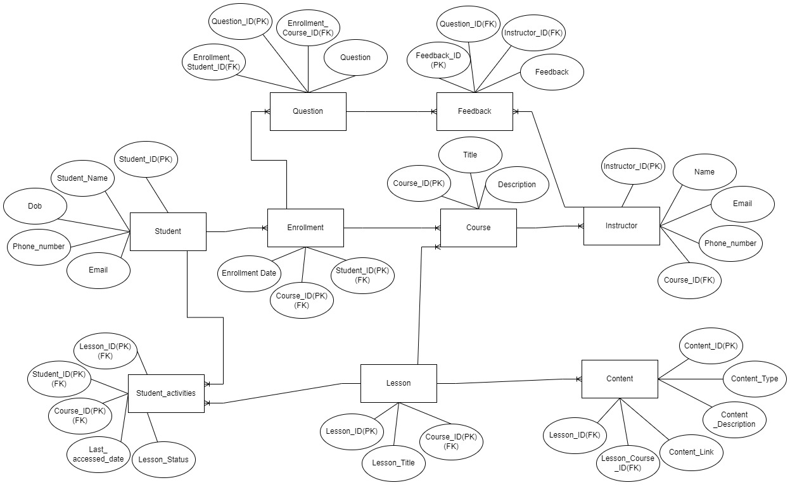

Figure 1:ER Diagram

# Data Dictionary

A database, information system, or research project's usage or capture of names, definitions, and characteristics of data pieces is called a data dictionary. It offers guidelines on interpretation, acceptable interpretations, and representation in addition to describing the aims and meanings of data items within the framework of a project. Metadata on data items is also provided via a data dictionary. The scope, properties, and application and usage guidelines of data items may all be defined with the help of the metadata that is provided in a data dictionary. (ucmerced, 2024)

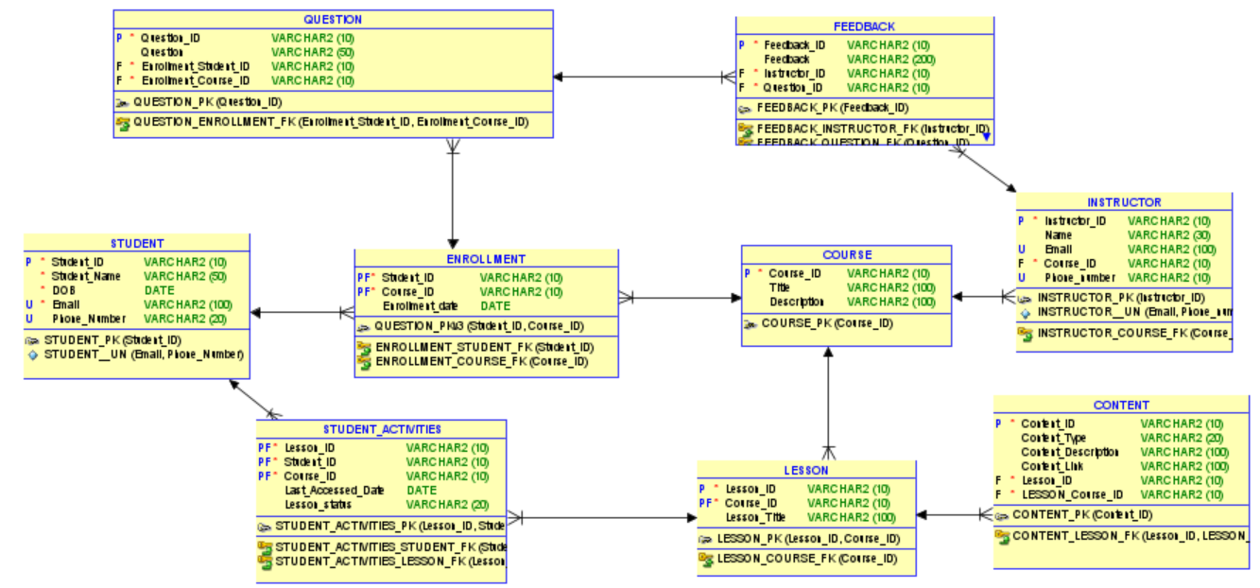

Figure 2: Data Dictionary

# Script

CREATE TABLE content (

content_id VARCHAR2(10) NOT NULL,

content_type VARCHAR2(20),

content_description VARCHAR2(20),

content_link VARCHAR2(100),

lesson_id VARCHAR2(10) NOT NULL,

lesson_course_id VARCHAR2(10)

);

ALTER TABLE content ADD CONSTRAINT content_pk PRIMARY KEY ( content_id );

CREATE TABLE course (

course_id VARCHAR2(10) NOT NULL,

title VARCHAR2(10),

desciption VARCHAR2(100)

);

ALTER TABLE course ADD CONSTRAINT course_pk PRIMARY KEY ( course_id );

CREATE TABLE enrollment (

student_id VARCHAR2(10) NOT NULL,

course_id VARCHAR2(10) NOT NULL,

enrollment_date DATE

);

ALTER TABLE enrollment ADD CONSTRAINT question_pkv3 PRIMARY KEY ( student_id,

course_id );

CREATE TABLE feedback (

feedback_id VARCHAR2(10),

feedback VARCHAR2(50),

instructor_id VARCHAR2(10) NOT NULL,

question_id VARCHAR2(10) NOT NULL

);

CREATE TABLE instructor (

instructor_id VARCHAR2(10) NOT NULL,

name VARCHAR2(30),

email VARCHAR2(30),

course_id VARCHAR2(10) NOT NULL,

phone_number VARCHAR2(10)

);

ALTER TABLE instructor ADD CONSTRAINT instructor_pk PRIMARY KEY ( instructor_id );

ALTER TABLE instructor ADD CONSTRAINT instructor__un UNIQUE ( email,

phone_number );

CREATE TABLE lesson (

lesson_id VARCHAR2(10) NOT NULL,

course_id VARCHAR2(10) NOT NULL,

lesson_title VARCHAR2(50)

);

ALTER TABLE lesson ADD CONSTRAINT lesson_pk PRIMARY KEY ( lesson_id,

course_id );

CREATE TABLE question (

question_id VARCHAR2(10) NOT NULL,

question VARCHAR2(50),

enrollment_student_id VARCHAR2(10) NOT NULL,

enrollment_course_id VARCHAR2(10) NOT NULL

);

ALTER TABLE question ADD CONSTRAINT question_pk PRIMARY KEY ( question_id );

CREATE TABLE student (

student_id VARCHAR2(10) NOT NULL,

student_name VARCHAR2(50) NOT NULL,

dob DATE NOT NULL,

email VARCHAR2(20) NOT NULL,

phone_number VARCHAR2(20)

);

ALTER TABLE student ADD CONSTRAINT student_pk PRIMARY KEY ( student_id );

ALTER TABLE student ADD CONSTRAINT student__un UNIQUE ( email,

phone_number );

CREATE TABLE student_activities (

lesson_id VARCHAR2(10) NOT NULL,

student_id VARCHAR2(10) NOT NULL,

course_id VARCHAR2(10) NOT NULL,

last_accessed_dtae DATE,

lesson_status VARCHAR2(20)

);

ALTER TABLE student_activities

ADD CONSTRAINT student_activities_pk PRIMARY KEY ( lesson_id,

student_id,

course_id );

ALTER TABLE content

ADD CONSTRAINT content_lesson_fk FOREIGN KEY ( lesson_id,

content_id )

REFERENCES lesson ( lesson_id,

course_id );

ALTER TABLE enrollment

ADD CONSTRAINT enrollment_course_fk FOREIGN KEY ( course_id )

REFERENCES course ( course_id );

ALTER TABLE enrollment

ADD CONSTRAINT enrollment_student_fk FOREIGN KEY ( student_id )

REFERENCES student ( student_id );

ALTER TABLE feedback

ADD CONSTRAINT feedback_instructor_fk FOREIGN KEY ( instructor_id )

REFERENCES instructor ( instructor_id );

ALTER TABLE feedback

ADD CONSTRAINT feedback_question_fk FOREIGN KEY ( question_id )

REFERENCES question ( question_id );

ALTER TABLE instructor

ADD CONSTRAINT instructor_course_fk FOREIGN KEY ( course_id )

REFERENCES course ( course_id );

ALTER TABLE lesson

ADD CONSTRAINT lesson_course_fk FOREIGN KEY ( course_id )

REFERENCES course ( course_id );

ALTER TABLE question

ADD CONSTRAINT question_enrollment_fk FOREIGN KEY ( enrollment_student_id,

enrollment_course_id )

REFERENCES enrollment ( student_id,

course_id );

ALTER TABLE student_activities

ADD CONSTRAINT student_activities_lesson_fk FOREIGN KEY ( lesson_id,

course_id )

REFERENCES lesson ( lesson_id,

course_id );

ALTER TABLE student_activities

ADD CONSTRAINT student_activities_student_fk FOREIGN KEY ( student_id )

REFERENCES student ( student_id );

# Inserting Values into the tables

## Inserting Value into students table

INSERT ALL

INTO student (student_id, student_name, dob, email, phone_number) VALUES ('S001', 'John Smith', TO_DATE('1995-05-15', 'YYYY-MM-DD'), 'john@gmail.com', '123-456-7890')

INTO student (student_id, student_name, dob, email, phone_number) VALUES ('S002', 'Jane Doe', TO_DATE('1996-08-25', 'YYYY-MM-DD'), 'jane@gmail.com', '987-654-3210')

INTO student (student_id, student_name, dob, email, phone_number) VALUES ('S003', 'Michael Johnson', TO_DATE('1994-11-10', 'YYYY-MM-DD'), 'michael@gmail.com', '456-789-0123')

INTO student (student_id, student_name, dob, email, phone_number) VALUES ('S004', 'Emily Brown', TO_DATE('1997-02-18', 'YYYY-MM-DD'), 'emily@gmail.com', '789-012-3456')

INTO student (student_id, student_name, dob, email, phone_number) VALUES ('S005', 'David Wilson', TO_DATE('1993-09-30', 'YYYY-MM-DD'), 'david@gmail.com', '321-654-0987')

INTO student (student_id, student_name, dob, email, phone_number) VALUES ('S006', 'Sarah Taylor', TO_DATE('1998-04-22', 'YYYY-MM-DD'), 'sarah@gmail.com', '654-321-9870')

INTO student (student_id, student_name, dob, email, phone_number) VALUES ('S007', 'James Martinez', TO_DATE('1992-12-05', 'YYYY-MM-DD'), 'james@gmail.com', '012-345-6789')

INTO student (student_id, student_name, dob, email, phone_number) VALUES ('S008', 'Jessica Anderson', TO_DATE('1999-07-17', 'YYYY-MM-DD'), 'jessica@gmail.com', '876-543-2109')

INTO student (student_id, student_name, dob, email, phone_number) VALUES ('S009', 'Daniel Hernandez', TO_DATE('1991-10-12', 'YYYY-MM-DD'), 'daniel@gmail.com', '234-567-8901')

INTO student (student_id, student_name, dob, email, phone_number) VALUES ('S010', 'Ashley Garcia', TO_DATE('1990-03-28', 'YYYY-MM-DD'), 'ashley@gmail.com', '543-210-9876')

INTO student (student_id, student_name, dob, email, phone_number) VALUES ('S011', 'Christopher Young', TO_DATE('1996-06-08', 'YYYY-MM-DD'), 'christopher@gmail.com', '890-123-4567')

INTO student (student_id, student_name, dob, email, phone_number) VALUES ('S012', 'Amanda Lewis', TO_DATE('1993-01-14', 'YYYY-MM-DD'), 'amanda@gmail.com', '432-109-8765')

INTO student (student_id, student_name, dob, email, phone_number) VALUES ('S013', 'Matthew Lee', TO_DATE('1998-08-02', 'YYYY-MM-DD'), 'matthew@gmail.com', '901-234-5678')

INTO student (student_id, student_name, dob, email, phone_number) VALUES ('S014', 'Nicole Walker', TO_DATE('1994-05-20', 'YYYY-MM-DD'), 'nicole@gmail.com', '210-987-6543')

INTO student (student_id, student_name, dob, email, phone_number) VALUES ('S015', 'Kevin Perez', TO_DATE('1995-12-01', 'YYYY-MM-DD'), 'kevin@gmail.com', '654-321-0987')

INTO student (student_id, student_name, dob, email, phone_number) VALUES ('S016', 'Brittany Wright', TO_DATE('1997-09-11', 'YYYY-MM-DD'), 'brittany@gmail.com', '543-210-9876')

INTO student (student_id, student_name, dob, email, phone_number) VALUES ('S017', 'Andrew Hill', TO_DATE('1992-04-29', 'YYYY-MM-DD'), 'andrew@gmail.com', '109-876-5432')

INTO student (student_id, student_name, dob, email, phone_number) VALUES ('S018', 'Samantha King', TO_DATE('1991-11-09', 'YYYY-MM-DD'), 'samantha@gmail.com', '678-901-2345')

INTO student (student_id, student_name, dob, email, phone_number) VALUES ('S019', 'Ryan Scott', TO_DATE('1990-02-15', 'YYYY-MM-DD'), 'ryan@gmail.com', '987-654-3210')

INTO student (student_id, student_name, dob, email, phone_number) VALUES ('S020', 'Lauren Green', TO_DATE('1993-07-26', 'YYYY-MM-DD'), 'lauren@gmail.com', '876-543-2109')

INTO student (student_id, student_name, dob, email, phone_number) VALUES ('S021', 'Justin Adams', TO_DATE('1996-10-05', 'YYYY-MM-DD'), 'justin@gmail.com', '456-789-0123')

INTO student (student_id, student_name, dob, email, phone_number) VALUES ('S022', 'Rachel Campbell', TO_DATE('1994-03-18', 'YYYY-MM-DD'), 'rachel@gmail.com', '765-432-1098')

INTO student (student_id, student_name, dob, email, phone_number) VALUES ('S023', 'Brandon Ramirez', TO_DATE('1998-06-29', 'YYYY-MM-DD'), 'brandon@gmail.com', '234-567-8901')

INTO student (student_id, student_name, dob, email, phone_number) VALUES ('S024', 'Melissa Torres', TO_DATE('1992-09-08', 'YYYY-MM-DD'), 'melissa@gmail.com', '543-210-9876')

INTO student (student_id, student_name, dob, email, phone_number) VALUES ('S025', 'Kyle Parker', TO_DATE('1995-12-11', 'YYYY-MM-DD'), 'kyle@gmail.com', '876-543-2109')

INTO student (student_id, student_name, dob, email, phone_number) VALUES ('S026', 'Alexis Evans', TO_DATE('1993-05-27', 'YYYY-MM-DD'), 'alexis@gmail.com', '210-987-6543')

INTO student (student_id, student_name, dob, email, phone_number) VALUES ('S027', 'Tyler Diaz', TO_DATE('1997-08-07', 'YYYY-MM-DD'), 'tyler@gmail.com', '987-654-3210')

INTO student (student_id, student_name, dob, email, phone_number) VALUES ('S028', 'Hannah Nelson', TO_DATE('1994-01-19', 'YYYY-MM-DD'), 'hannah@gmail.com', '765-432-1098')

INTO student (student_id, student_name, dob, email, phone_number) VALUES ('S029', 'Benjamin Murphy', TO_DATE('1991-04-24', 'YYYY-MM-DD'), 'benjamin@gmail.com', '234-567-8901')

INTO student (student_id, student_name, dob, email, phone_number) VALUES ('S030', 'Kayla Cooper', TO_DATE('1998-03-05', 'YYYY-MM-DD'), 'kayla@gmail.com', '543-210-9876')

SELECT * FROM DUAL;

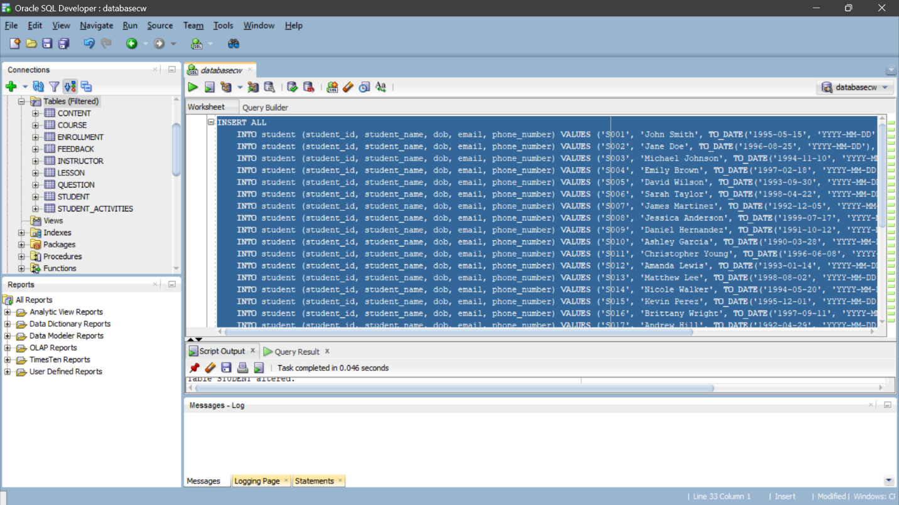

Figure 3: inserting value into student table

## Inserting Value into course table

INSERT ALL

INTO course (course_id, title, description) VALUES ('C001', 'Math', 'Introduction to Mathematics')

INTO course (course_id, title, description) VALUES ('C002', 'English', 'Introduction to English Literature')

INTO course (course_id, title, description) VALUES ('C003', 'History', 'World History: From Ancient Times to Present')

INTO course (course_id, title, description) VALUES ('C004', 'Biology', 'Introduction to Biology: Basics of Life')

INTO course (course_id, title, description) VALUES ('C005', 'Chemistry', 'Fundamentals of Chemistry')

INTO course (course_id, title, description) VALUES ('C006', 'Physics', 'Introduction to Physics: Laws of Nature')

INTO course (course_id, title, description) VALUES ('C007', 'Computer Science', 'Introduction to Computer Science and Programming')

INTO course (course_id, title, description) VALUES ('C008', 'Art', 'Exploring Art: Creativity and Expression')

INTO course (course_id, title, description) VALUES ('C009', 'Music', 'Music Appreciation: Understanding the Elements of Music')

INTO course (course_id, title, description) VALUES ('C010', 'Psychology', 'Introduction to Psychology: Understanding the Mind')

INTO course (course_id, title, description) VALUES ('C011', 'Sociology', 'Introduction to Sociology: Study of Society')

INTO course (course_id, title, description) VALUES ('C012', 'Economics', 'Principles of Economics: Understanding Markets and Economies')

INTO course (course_id, title, description) VALUES ('C013', 'Philosophy', 'Introduction to Philosophy: Questions about Existence and Reality')

INTO course (course_id, title, description) VALUES ('C014', 'Political Science', 'Introduction to Political Science: Understanding Politics')

INTO course (course_id, title, description) VALUES ('C015', 'Geography', 'Physical and Human Geography: Exploring the World')

INTO course (course_id, title, description) VALUES ('C016', 'Literature', 'Exploring Literature: Appreciating Literary Works')

INTO course (course_id, title, description) VALUES ('C017', 'Foreign Language', 'Learning a Foreign Language: Basics of Communication')

INTO course (course_id, title, description) VALUES ('C018', 'Health', 'Health and Wellness: Taking Care of Your Body and Mind')

INTO course (course_id, title, description) VALUES ('C019', 'Environmental Science', 'Introduction to Environmental Science: Understanding the Environment')

INTO course (course_id, title, description) VALUES ('C020', 'Physical Education', 'Physical Fitness and Sports: Importance of Exercise')

INTO course (course_id, title, description) VALUES ('C021', 'Engineering', 'Introduction to Engineering: Principles and Applications')

INTO course (course_id, title, description) VALUES ('C022', 'Business', 'Introduction to Business: Fundamentals of Commerce')

INTO course (course_id, title, description) VALUES ('C023', 'Marketing', 'Principles of Marketing: Understanding Consumer Behavior')

INTO course (course_id, title, description) VALUES ('C024', 'Finance', 'Introduction to Finance: Managing Money and Investments')

INTO course (course_id, title, description) VALUES ('C025', 'Communication', 'Effective Communication: Skills for Success')

INTO course (course_id, title, description) VALUES ('C026', 'Anthropology', 'Introduction to Anthropology: Study of Human Societies and Cultures')

INTO course (course_id, title, description) VALUES ('C027', 'Criminal Justice', 'Introduction to Criminal Justice: Understanding Law and Order')

INTO course (course_id, title, description) VALUES ('C028', 'Education', 'Foundations of Education: Learning and Teaching Principles')

INTO course (course_id, title, description) VALUES ('C029', 'Nursing', 'Fundamentals of Nursing: Basics of Patient Care')

INTO course (course_id, title, description) VALUES ('C030', 'Architecture', 'Introduction to Architecture: Design and Construction Principles')

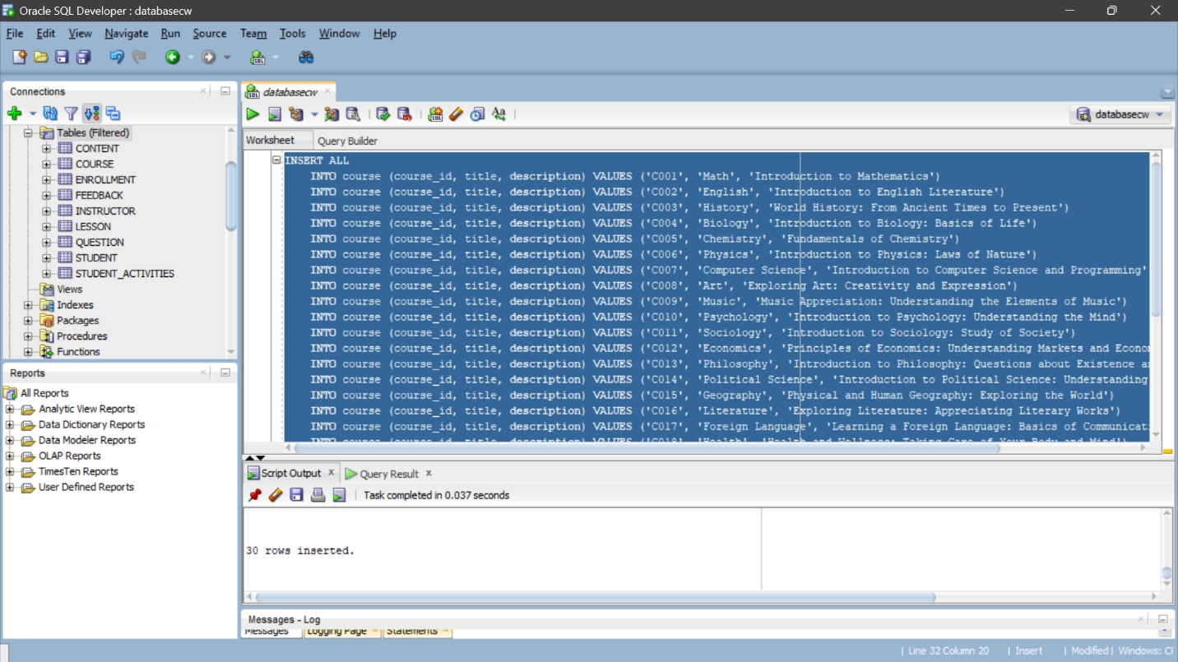SELECT * FROM DUAL;

Figure 4: inserting value into course table

## Inserting value into enrollment table

INSERT ALL

INTO enrollment (student_id, course_id, enrollment_date) VALUES ('S001', 'C001', TO_DATE('2024-03-17', 'YYYY-MM-DD'))

INTO enrollment (student_id, course_id, enrollment_date) VALUES ('S002', 'C002', TO_DATE('2024-03-17', 'YYYY-MM-DD'))

INTO enrollment (student_id, course_id, enrollment_date) VALUES ('S003', 'C003', TO_DATE('2024-03-17', 'YYYY-MM-DD'))

INTO enrollment (student_id, course_id, enrollment_date) VALUES ('S004', 'C001', TO_DATE('2024-03-17', 'YYYY-MM-DD'))

INTO enrollment (student_id, course_id, enrollment_date) VALUES ('S005', 'C002', TO_DATE('2024-03-17', 'YYYY-MM-DD'))

INTO enrollment (student_id, course_id, enrollment_date) VALUES ('S006', 'C003', TO_DATE('2024-03-17', 'YYYY-MM-DD'))

INTO enrollment (student_id, course_id, enrollment_date) VALUES ('S007', 'C001', TO_DATE('2024-03-17', 'YYYY-MM-DD'))

INTO enrollment (student_id, course_id, enrollment_date) VALUES ('S008', 'C002', TO_DATE('2024-03-17', 'YYYY-MM-DD'))

INTO enrollment (student_id, course_id, enrollment_date) VALUES ('S009', 'C003', TO_DATE('2024-03-17', 'YYYY-MM-DD'))

INTO enrollment (student_id, course_id, enrollment_date) VALUES ('S010', 'C001', TO_DATE('2024-03-17', 'YYYY-MM-DD'))

INTO enrollment (student_id, course_id, enrollment_date) VALUES ('S011', 'C002', TO_DATE('2024-03-17', 'YYYY-MM-DD'))

INTO enrollment (student_id, course_id, enrollment_date) VALUES ('S012', 'C003', TO_DATE('2024-03-17', 'YYYY-MM-DD'))

INTO enrollment (student_id, course_id, enrollment_date) VALUES ('S013', 'C001', TO_DATE('2024-03-17', 'YYYY-MM-DD'))

INTO enrollment (student_id, course_id, enrollment_date) VALUES ('S014', 'C002', TO_DATE('2024-03-17', 'YYYY-MM-DD'))

INTO enrollment (student_id, course_id, enrollment_date) VALUES ('S015', 'C003', TO_DATE('2024-03-17', 'YYYY-MM-DD'))

INTO enrollment (student_id, course_id, enrollment_date) VALUES ('S016', 'C001', TO_DATE('2024-03-17', 'YYYY-MM-DD'))

INTO enrollment (student_id, course_id, enrollment_date) VALUES ('S017', 'C002', TO_DATE('2024-03-17', 'YYYY-MM-DD'))

INTO enrollment (student_id, course_id, enrollment_date) VALUES ('S018', 'C003', TO_DATE('2024-03-17', 'YYYY-MM-DD'))

INTO enrollment (student_id, course_id, enrollment_date) VALUES ('S019', 'C001', TO_DATE('2024-03-17', 'YYYY-MM-DD'))

INTO enrollment (student_id, course_id, enrollment_date) VALUES ('S020', 'C002', TO_DATE('2024-03-17', 'YYYY-MM-DD'))

INTO enrollment (student_id, course_id, enrollment_date) VALUES ('S021', 'C003', TO_DATE('2024-03-17', 'YYYY-MM-DD'))

INTO enrollment (student_id, course_id, enrollment_date) VALUES ('S022', 'C001', TO_DATE('2024-03-17', 'YYYY-MM-DD'))

INTO enrollment (student_id, course_id, enrollment_date) VALUES ('S023', 'C002', TO_DATE('2024-03-17', 'YYYY-MM-DD'))

INTO enrollment (student_id, course_id, enrollment_date) VALUES ('S024', 'C003', TO_DATE('2024-03-17', 'YYYY-MM-DD'))

INTO enrollment (student_id, course_id, enrollment_date) VALUES ('S025', 'C001', TO_DATE('2024-03-17', 'YYYY-MM-DD'))

INTO enrollment (student_id, course_id, enrollment_date) VALUES ('S026', 'C002', TO_DATE('2024-03-17', 'YYYY-MM-DD'))

INTO enrollment (student_id, course_id, enrollment_date) VALUES ('S027', 'C003', TO_DATE('2024-03-17', 'YYYY-MM-DD'))

INTO enrollment (student_id, course_id, enrollment_date) VALUES ('S028', 'C001', TO_DATE('2024-03-17', 'YYYY-MM-DD'))

INTO enrollment (student_id, course_id, enrollment_date) VALUES ('S029', 'C002', TO_DATE('2024-03-17', 'YYYY-MM-DD'))

INTO enrollment (student_id, course_id, enrollment_date) VALUES ('S030', 'C003', TO_DATE('2024-03-17', 'YYYY-MM-DD'))

SELECT * FROM DUAL;

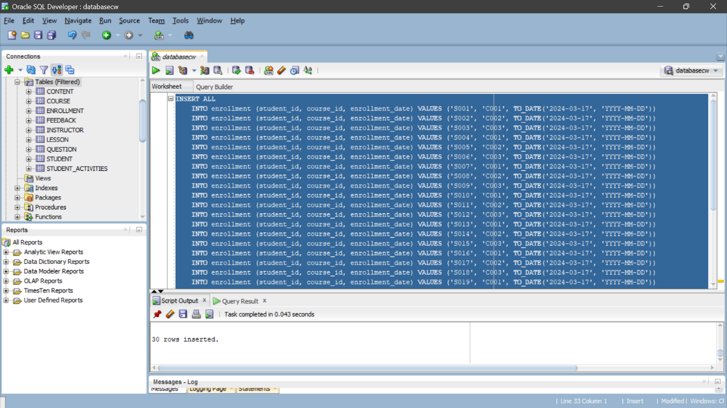

Figure 5: inserting value into enrolment table

## Inserting value into lesson table

INSERT ALL

INTO lesson (lesson_id, course_id, lesson_title) VALUES ('L001', 'C001', 'Introduction to Programming')

INTO lesson (lesson_id, course_id, lesson_title) VALUES ('L002', 'C001', 'Variables and Data Types')

INTO lesson (lesson_id, course_id, lesson_title) VALUES ('L003', 'C001', 'Control Statements')

INTO lesson (lesson_id, course_id, lesson_title) VALUES ('L004', 'C002', 'Introduction to Databases')

INTO lesson (lesson_id, course_id, lesson_title) VALUES ('L005', 'C002', 'SQL Basics')

INTO lesson (lesson_id, course_id, lesson_title) VALUES ('L006', 'C002', 'Advanced SQL Queries')

INTO lesson (lesson_id, course_id, lesson_title) VALUES ('L007', 'C003', 'Introduction to Web Development')

INTO lesson (lesson_id, course_id, lesson_title) VALUES ('L008', 'C003', 'HTML Basics')

INTO lesson (lesson_id, course_id, lesson_title) VALUES ('L009', 'C003', 'CSS Styling')

INTO lesson (lesson_id, course_id, lesson_title) VALUES ('L010', 'C004', 'Introduction to Machine Learning')

INTO lesson (lesson_id, course_id, lesson_title) VALUES ('L011', 'C004', 'Supervised Learning')

INTO lesson (lesson_id, course_id, lesson_title) VALUES ('L012', 'C004', 'Unsupervised Learning')

INTO lesson (lesson_id, course_id, lesson_title) VALUES ('L013', 'C005', 'Introduction to Data Science')

INTO lesson (lesson_id, course_id, lesson_title) VALUES ('L014', 'C005', 'Data Preprocessing')

INTO lesson (lesson_id, course_id, lesson_title) VALUES ('L015', 'C005', 'Data Visualization')

INTO lesson (lesson_id, course_id, lesson_title) VALUES ('L016', 'C006', 'Introduction to Cybersecurity')

INTO lesson (lesson_id, course_id, lesson_title) VALUES ('L017', 'C006', 'Network Security')

INTO lesson (lesson_id, course_id, lesson_title) VALUES ('L018', 'C006', 'Cryptography')

INTO lesson (lesson_id, course_id, lesson_title) VALUES ('L019', 'C007', 'Introduction to Robotics')

INTO lesson (lesson_id, course_id, lesson_title) VALUES ('L020', 'C007', 'Robotics Programming')

INTO lesson (lesson_id, course_id, lesson_title) VALUES ('L021', 'C007', 'Robotics Sensors')

INTO lesson (lesson_id, course_id, lesson_title) VALUES ('L022', 'C008', 'Introduction to Financial Markets')

INTO lesson (lesson_id, course_id, lesson_title) VALUES ('L023', 'C008', 'Stock Market Analysis')

INTO lesson (lesson_id, course_id, lesson_title) VALUES ('L024', 'C008', 'Investment Strategies')

INTO lesson (lesson_id, course_id, lesson_title) VALUES ('L025', 'C009', 'Introduction to Graphic Design')

INTO lesson (lesson_id, course_id, lesson_title) VALUES ('L026', 'C009', 'Digital Illustration')

INTO lesson (lesson_id, course_id, lesson_title) VALUES ('L027', 'C009', 'Typography')

INTO lesson (lesson_id, course_id, lesson_title) VALUES ('L028', 'C010', 'Introduction to Ethical Hacking')

INTO lesson (lesson_id, course_id, lesson_title) VALUES ('L029', 'C010', 'Penetration Testing')

INTO lesson (lesson_id, course_id, lesson_title) VALUES ('L030', 'C010', 'Security Tools')

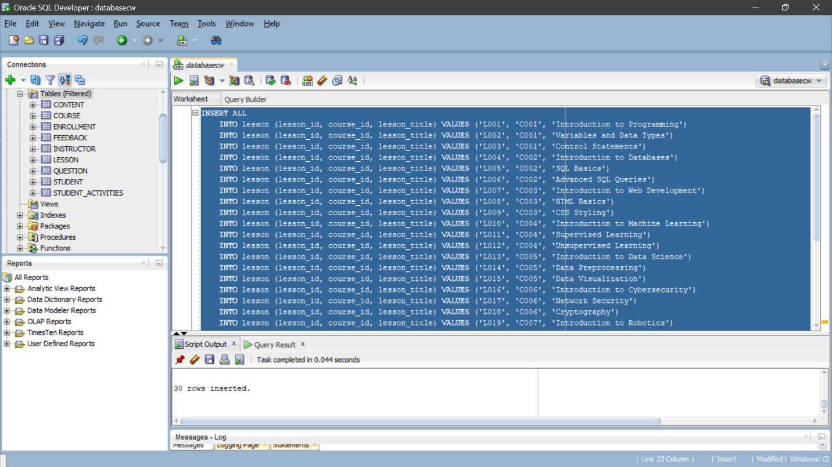SELECT * FROM DUAL;

Figure 6: Inserting value into lesson table

## Inserting value into student activities table

INSERT ALL

INTO student_activities (lesson_id, student_id, course_id, last_accessed_date, lesson_status) VALUES ('L001', 'S001', 'C001', TO_DATE('2024-03-17', 'YYYY-MM-DD'), 'Completed')

INTO student_activities (lesson_id, student_id, course_id, last_accessed_date, lesson_status) VALUES ('L002', 'S001', 'C001', TO_DATE('2024-03-17', 'YYYY-MM-DD'), 'InProgress')

INTO student_activities (lesson_id, student_id, course_id, last_accessed_date, lesson_status) VALUES ('L003', 'S001', 'C001', TO_DATE('2024-03-17', 'YYYY-MM-DD'), 'NotStarted')

INTO student_activities (lesson_id, student_id, course_id, last_accessed_date, lesson_status) VALUES ('L001', 'S002', 'C001', TO_DATE('2024-03-17', 'YYYY-MM-DD'), 'Completed')

INTO student_activities (lesson_id, student_id, course_id, last_accessed_date, lesson_status) VALUES ('L002', 'S002', 'C001', TO_DATE('2024-03-17', 'YYYY-MM-DD'), 'InProgress')

INTO student_activities (lesson_id, student_id, course_id, last_accessed_date, lesson_status) VALUES ('L003', 'S002', 'C001', TO_DATE('2024-03-17', 'YYYY-MM-DD'), 'NotStarted')

INTO student_activities (lesson_id, student_id, course_id, last_accessed_date, lesson_status) VALUES ('L001', 'S003', 'C001', TO_DATE('2024-03-17', 'YYYY-MM-DD'), 'Completed')

INTO student_activities (lesson_id, student_id, course_id, last_accessed_date, lesson_status) VALUES ('L002', 'S003', 'C001', TO_DATE('2024-03-17', 'YYYY-MM-DD'), 'InProgress')

INTO student_activities (lesson_id, student_id, course_id, last_accessed_date, lesson_status) VALUES ('L003', 'S003', 'C001', TO_DATE('2024-03-17', 'YYYY-MM-DD'), 'NotStarted')

INTO student_activities (lesson_id, student_id, course_id, last_accessed_date, lesson_status) VALUES ('L001', 'S004', 'C001', TO_DATE('2024-03-17', 'YYYY-MM-DD'), 'Completed')

INTO student_activities (lesson_id, student_id, course_id, last_accessed_date, lesson_status) VALUES ('L002', 'S004', 'C001', TO_DATE('2024-03-17', 'YYYY-MM-DD'), 'InProgress')

INTO student_activities (lesson_id, student_id, course_id, last_accessed_date, lesson_status) VALUES ('L003', 'S004', 'C001', TO_DATE('2024-03-17', 'YYYY-MM-DD'), 'NotStarted')

INTO student_activities (lesson_id, student_id, course_id, last_accessed_date, lesson_status) VALUES ('L001', 'S005', 'C001', TO_DATE('2024-03-17', 'YYYY-MM-DD'), 'Completed')

INTO student_activities (lesson_id, student_id, course_id, last_accessed_date, lesson_status) VALUES ('L002', 'S005', 'C001', TO_DATE('2024-03-17', 'YYYY-MM-DD'), 'InProgress')

INTO student_activities (lesson_id, student_id, course_id, last_accessed_date, lesson_status) VALUES ('L003', 'S005', 'C001', TO_DATE('2024-03-17', 'YYYY-MM-DD'), 'NotStarted')

INTO student_activities (lesson_id, student_id, course_id, last_accessed_date, lesson_status) VALUES ('L001', 'S006', 'C001', TO_DATE('2024-03-17', 'YYYY-MM-DD'), 'Completed')

INTO student_activities (lesson_id, student_id, course_id, last_accessed_date, lesson_status) VALUES ('L002', 'S006', 'C001', TO_DATE('2024-03-17', 'YYYY-MM-DD'), 'InProgress')

INTO student_activities (lesson_id, student_id, course_id, last_accessed_date, lesson_status) VALUES ('L003', 'S006', 'C001', TO_DATE('2024-03-17', 'YYYY-MM-DD'), 'NotStarted')

INTO student_activities (lesson_id, student_id, course_id, last_accessed_date, lesson_status) VALUES ('L001', 'S007', 'C001', TO_DATE('2024-03-17', 'YYYY-MM-DD'), 'Completed')

INTO student_activities (lesson_id, student_id, course_id, last_accessed_date, lesson_status) VALUES ('L002', 'S007', 'C001', TO_DATE('2024-03-17', 'YYYY-MM-DD'), 'InProgress')

INTO student_activities (lesson_id, student_id, course_id, last_accessed_date, lesson_status) VALUES ('L003', 'S007', 'C001', TO_DATE('2024-03-17', 'YYYY-MM-DD'), 'NotStarted')

INTO student_activities (lesson_id, student_id, course_id, last_accessed_date, lesson_status) VALUES ('L001', 'S008', 'C001', TO_DATE('2024-03-17', 'YYYY-MM-DD'), 'Completed')

INTO student_activities (lesson_id, student_id, course_id, last_accessed_date, lesson_status) VALUES ('L002', 'S008', 'C001', TO_DATE('2024-03-17', 'YYYY-MM-DD'), 'InProgress')

INTO student_activities (lesson_id, student_id, course_id, last_accessed_date, lesson_status) VALUES ('L003', 'S008', 'C001', TO_DATE('2024-03-17', 'YYYY-MM-DD'), 'NotStarted')

INTO student_activities (lesson_id, student_id, course_id, last_accessed_date, lesson_status) VALUES ('L001', 'S009', 'C001', TO_DATE('2024-03-17', 'YYYY-MM-DD'), 'Completed')

INTO student_activities (lesson_id, student_id, course_id, last_accessed_date, lesson_status) VALUES ('L002', 'S009', 'C001', TO_DATE('2024-03-17', 'YYYY-MM-DD'), 'InProgress')

INTO student_activities (lesson_id, student_id, course_id, last_accessed_date, lesson_status) VALUES ('L003', 'S009', 'C001', TO_DATE('2024-03-17', 'YYYY-MM-DD'), 'NotStarted')

INTO student_activities (lesson_id, student_id, course_id, last_accessed_date, lesson_status) VALUES ('L001', 'S010', 'C001', TO_DATE('2024-03-17', 'YYYY-MM-DD'), 'Completed')

INTO student_activities (lesson_id, student_id, course_id, last_accessed_date, lesson_status) VALUES ('L002', 'S010', 'C001', TO_DATE('2024-03-17', 'YYYY-MM-DD'), 'InProgress')

INTO student_activities (lesson_id, student_id, course_id, last_accessed_date, lesson_status) VALUES ('L003', 'S010', 'C001', TO_DATE('2024-03-17', 'YYYY-MM-DD'), 'NotStarted')

SELECT * FROM DUAL;

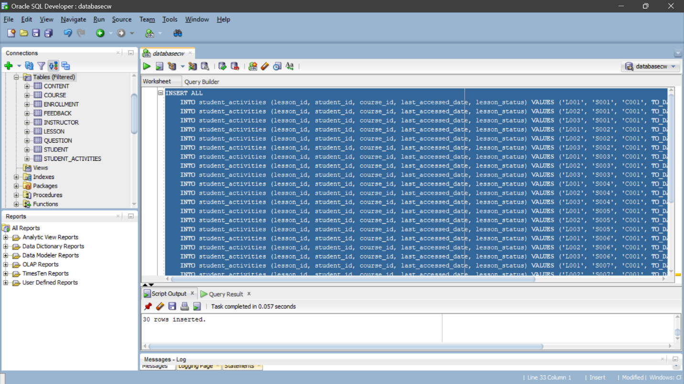

Figure 7: Inserting value into student activities table

## Inserting value into content table

INSERT ALL

INTO content (content_id, content_type, content_description, content_link, lesson_id, lesson_course_id) VALUES ('C001', 'Video', 'Introduction', 'https://learnm.com/introduction', 'L001', 'C001')

INTO content (content_id, content_type, content_description, content_link, lesson_id, lesson_course_id) VALUES ('C002', 'Article', 'Basics of Programming', 'https://learnm.com/basics', 'L002', 'C001')

INTO content (content_id, content_type, content_description, content_link, lesson_id, lesson_course_id) VALUES ('C003', 'Quiz', 'Test Your Knowledge', 'https://learnm.com/quiz', 'L003', 'C001')

INTO content (content_id, content_type, content_description, content_link, lesson_id, lesson_course_id) VALUES ('C004', 'Video', 'Intermediate Concepts', 'https://learnm.com/intermediate', 'L004', 'C002')

INTO content (content_id, content_type, content_description, content_link, lesson_id, lesson_course_id) VALUES ('C005', 'Article', 'Advanced Techniques', 'https://learnm.com/advanced', 'L005', 'C002')

INTO content (content_id, content_type, content_description, content_link, lesson_id, lesson_course_id) VALUES ('C006', 'Quiz', 'Assessment', 'https://learnm.com/assessment', 'L006', 'C002')

INTO content (content_id, content_type, content_description, content_link, lesson_id, lesson_course_id) VALUES ('C007', 'Video', 'Final Lesson', 'https://learnm.com/final', 'L007', 'C003')

INTO content (content_id, content_type, content_description, content_link, lesson_id, lesson_course_id) VALUES ('C008', 'Article', 'Conclusion', 'https://learnm.com/conclusion', 'L008', 'C003')

INTO content (content_id, content_type, content_description, content_link, lesson_id, lesson_course_id) VALUES ('C009', 'Quiz', 'Final Exam', 'https://learnm.com/final-quiz', 'L009', 'C003')

INTO content (content_id, content_type, content_description, content_link, lesson_id, lesson_course_id) VALUES ('C010', 'Video', 'Introduction', 'https://learnm.com/introduction', 'L001', 'C001')

INTO content (content_id, content_type, content_description, content_link, lesson_id, lesson_course_id) VALUES ('C011', 'Article', 'Basics of Programming', 'https://learnm.com/basics', 'L002', 'C001')

INTO content (content_id, content_type, content_description, content_link, lesson_id, lesson_course_id) VALUES ('C012', 'Quiz', 'Test Your Knowledge', 'https://learnm.com/quiz', 'L003', 'C001')

INTO content (content_id, content_type, content_description, content_link, lesson_id, lesson_course_id) VALUES ('C013', 'Video', 'Intermediate Concepts', 'https://learnm.com/intermediate', 'L004', 'C002')

INTO content (content_id, content_type, content_description, content_link, lesson_id, lesson_course_id) VALUES ('C014', 'Article', 'Advanced Techniques', 'https://learnm.com/advanced', 'L005', 'C002')

INTO content (content_id, content_type, content_description, content_link, lesson_id, lesson_course_id) VALUES ('C015', 'Quiz', 'Assessment', 'https://learnm.com/assessment', 'L006', 'C002')

INTO content (content_id, content_type, content_description, content_link, lesson_id, lesson_course_id) VALUES ('C016', 'Video', 'Final Lesson', 'https://learnm.com/final', 'L007', 'C003')

INTO content (content_id, content_type, content_description, content_link, lesson_id, lesson_course_id) VALUES ('C017', 'Article', 'Conclusion', 'https://learnm.com/conclusion', 'L008', 'C003')

INTO content (content_id, content_type, content_description, content_link, lesson_id, lesson_course_id) VALUES ('C018', 'Quiz', 'Final Exam', 'https://learnm.com/final-quiz', 'L009', 'C003')

INTO content (content_id, content_type, content_description, content_link, lesson_id, lesson_course_id) VALUES ('C019', 'Video', 'Introduction', 'https://learnm.com/introduction', 'L010', 'C004')

INTO content (content_id, content_type, content_description, content_link, lesson_id, lesson_course_id) VALUES ('C020', 'Article', 'Basics of Programming', 'https://learnm.com/basics', 'L011', 'C004')

INTO content (content_id, content_type, content_description, content_link, lesson_id, lesson_course_id) VALUES ('C021', 'Quiz', 'Test Your Knowledge', 'https://learnm.com/quiz', 'L012', 'C004')

INTO content (content_id, content_type, content_description, content_link, lesson_id, lesson_course_id) VALUES ('C022', 'Video', 'Intermediate Concepts', 'https://learnm.com/intermediate', 'L010', 'C004')

INTO content (content_id, content_type, content_description, content_link, lesson_id, lesson_course_id) VALUES ('C023', 'Article', 'Advanced Techniques', 'https://learnm.com/advanced', 'L011', 'C004')

INTO content (content_id, content_type, content_description, content_link, lesson_id, lesson_course_id) VALUES ('C024', 'Quiz', 'Assessment', 'https://learnm.com/assessment', 'L012', 'C004')

INTO content (content_id, content_type, content_description, content_link, lesson_id, lesson_course_id) VALUES ('C025', 'Video', 'Final Lesson', 'https://learnm.com/final', 'L010', 'C004')

INTO content (content_id, content_type, content_description, content_link, lesson_id, lesson_course_id) VALUES ('C026', 'Article', 'Conclusion', 'https://learnm.com/conclusion', 'L011', 'C004')

INTO content (content_id, content_type, content_description, content_link, lesson_id, lesson_course_id) VALUES ('C027', 'Quiz', 'Final Exam', 'https://learnm.com/final-quiz', 'L012', 'C004')

INTO content (content_id, content_type, content_description, content_link, lesson_id, lesson_course_id) VALUES ('C028', 'Video', 'Introduction', 'https://learnm.com/introduction', 'L013', 'C005')

INTO content (content_id, content_type, content_description, content_link, lesson_id, lesson_course_id) VALUES ('C029', 'Article', 'Basics of Programming', 'https://learnm.com/basics', 'L014', 'C005')

INTO content (content_id, content_type, content_description, content_link, lesson_id, lesson_course_id) VALUES ('C030', 'Article ', 'Report writing', 'https://learnm.com/report', 'L015', 'C005')

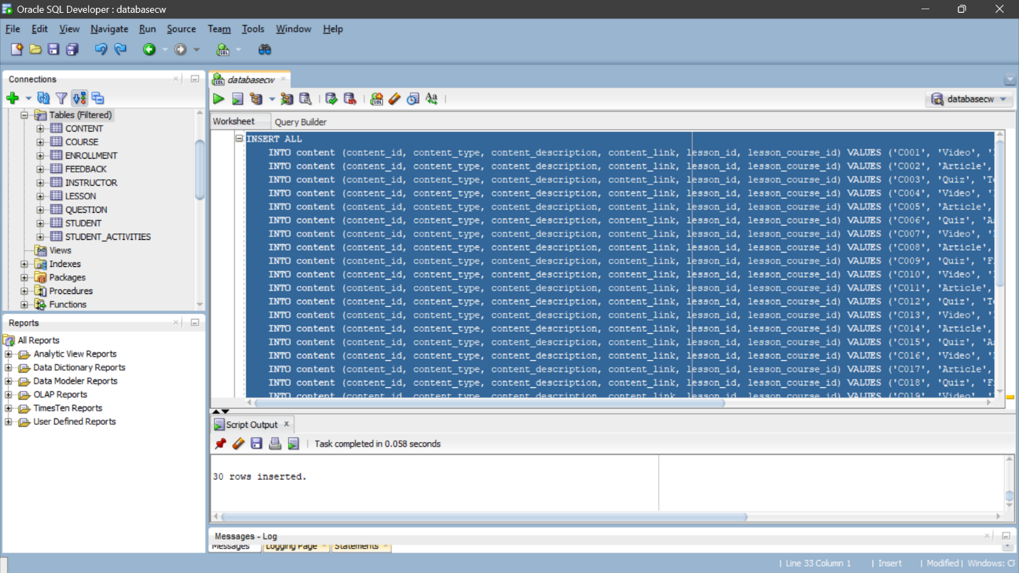SELECT * FROM DUAL;

Figure 8: Inserting value into content table

## Inserting value into instructor table

INSERT ALL

INTO instructor (instructor_id, name, email, course_id, phone_number) VALUES ('I001', 'John Doe', 'john@gmail.com', 'C001', '1234567890')

INTO instructor (instructor_id, name, email, course_id, phone_number) VALUES ('I002', 'Jane Smith', 'jane@gmail.com', 'C002', '9876543210')

INTO instructor (instructor_id, name, email, course_id, phone_number) VALUES ('I003', 'Michael Johnson', 'michael@gmail.com', 'C003', '5554443333')

INTO instructor (instructor_id, name, email, course_id, phone_number) VALUES ('I004', 'Emily Brown', 'emily@gmail.com', 'C004', '1112223333')

INTO instructor (instructor_id, name, email, course_id, phone_number) VALUES ('I005', 'David Wilson', 'david@gmail.com', 'C005', '4445556666')

INTO instructor (instructor_id, name, email, course_id, phone_number) VALUES ('I006', 'Emma Taylor', 'emma@gmail.com', 'C006', '7778889999')

INTO instructor (instructor_id, name, email, course_id, phone_number) VALUES ('I007', 'James Martinez', 'james@gmail.com', 'C007', '2223334444')

INTO instructor (instructor_id, name, email, course_id, phone_number) VALUES ('I008', 'Olivia Anderson', 'olivia@gmail.com', 'C008', '6667778888')

INTO instructor (instructor_id, name, email, course_id, phone_number) VALUES ('I009', 'William Thomas', 'william@gmail.com', 'C009', '9990001111')

INTO instructor (instructor_id, name, email, course_id, phone_number) VALUES ('I010', 'Sophia Garcia', 'sophia@gmail.com', 'C010', '3332221111')

INTO instructor (instructor_id, name, email, course_id, phone_number) VALUES ('I011', 'Benjamin Rodriguez', 'benjamin@gmail.com', 'C011', '8889990000')

INTO instructor (instructor_id, name, email, course_id, phone_number) VALUES ('I012', 'Mia Martinez', 'mia@gmail.com', 'C012', '5556667777')

INTO instructor (instructor_id, name, email, course_id, phone_number) VALUES ('I013', 'Ethan Hernandez', 'ethan@gmail.com', 'C013', '2221110000')

INTO instructor (instructor_id, name, email, course_id, phone_number) VALUES ('I014', 'Charlotte Smith', 'charlotte@gmail.com', 'C014', '7778889999')

INTO instructor (instructor_id, name, email, course_id, phone_number) VALUES ('I015', 'Alexander Wilson', 'alexander@gmail.com', 'C015', '4445556666')

INTO instructor (instructor_id, name, email, course_id, phone_number) VALUES ('I016', 'Amelia Johnson', 'amelia@gmail.com', 'C016', '1112223333')

INTO instructor (instructor_id, name, email, course_id, phone_number) VALUES ('I017', 'Jacob Brown', 'jacob@gmail.com', 'C017', '6667778888')

INTO instructor (instructor_id, name, email, course_id, phone_number) VALUES ('I018', 'Ava Taylor', 'ava@gmail.com', 'C018', '9990001111')

INTO instructor (instructor_id, name, email, course_id, phone_number) VALUES ('I019', 'Daniel Martinez', 'daniel@gmail.com', 'C019', '3332221111')

INTO instructor (instructor_id, name, email, course_id, phone_number) VALUES ('I020', 'Oliver Johnson', 'oliver@gmail.com', 'C020', '8889990000')

INTO instructor (instructor_id, name, email, course_id, phone_number) VALUES ('I021', 'Sophia Hernandez', 'sophia@gmail.com', 'C021', '5556667777')

INTO instructor (instructor_id, name, email, course_id, phone_number) VALUES ('I022', 'Emma Garcia', 'emma@gmail.com', 'C022', '2221110000')

INTO instructor (instructor_id, name, email, course_id, phone_number) VALUES ('I023', 'Lucas Rodriguez', 'lucas@gmail.com', 'C023', '7778889999')

INTO instructor (instructor_id, name, email, course_id, phone_number) VALUES ('I024', 'Ava Brown', 'ava@gmail.com', 'C024', '4445556666')

INTO instructor (instructor_id, name, email, course_id, phone_number) VALUES ('I025', 'Logan Smith', 'logan@gmail.com', 'C025', '1112223333')

INTO instructor (instructor_id, name, email, course_id, phone_number) VALUES ('I026', 'Isabella Wilson', 'isabella@gmail.com', 'C026', '6667778888')

INTO instructor (instructor_id, name, email, course_id, phone_number) VALUES ('I027', 'Mia Johnson', 'mia@gmail.com', 'C027', '9990001111')

INTO instructor (instructor_id, name, email, course_id, phone_number) VALUES ('I028', 'Jackson Taylor', 'jackson@gmail.com', 'C028', '3332221111')

INTO instructor (instructor_id, name, email, course_id, phone_number) VALUES ('I029', 'Aiden Martinez', 'aiden@gmail.com', 'C029', '8889990000')

INTO instructor (instructor_id, name, email, course_id, phone_number) VALUES ('I030', 'Sophie Hernandez', 'sophie@gmail.com', 'C030', '5556667777')

SELECT * FROM DUAL;

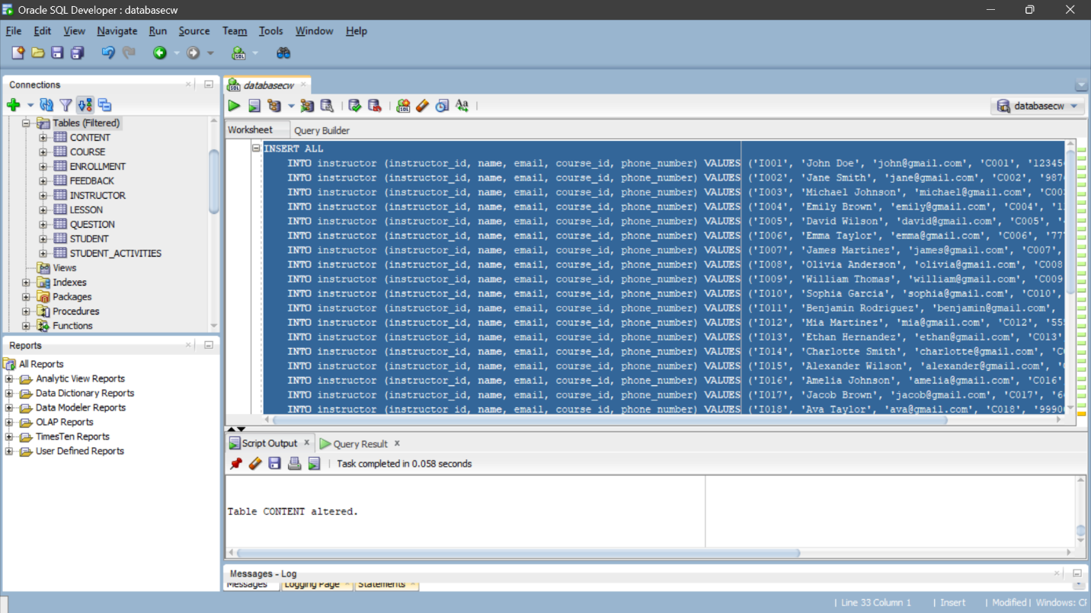

Figure 9: Inserting value into instructor table

## Inserting value into question table

INSERT ALL

INTO question (question_id, question, enrollment_student_id, enrollment_course_id) VALUES ('Q001', 'How satisfied are you with the course materials?', 'S001', 'C001')

INTO question (question_id, question, enrollment_student_id, enrollment_course_id) VALUES ('Q002', 'Did the instructor effectively communicate the concepts?', 'S002', 'C002')

INTO question (question_id, question, enrollment_student_id, enrollment_course_id) VALUES ('Q003', 'Were the assignments helpful for your learning?', 'S003', 'C003')

INTO question (question_id, question, enrollment_student_id, enrollment_course_id) VALUES ('Q004', 'How would you rate your overall experience?', 'S004', 'C001')

INTO question (question_id, question, enrollment_student_id, enrollment_course_id) VALUES ('Q005', 'Did you find the course content challenging?', 'S005', 'C002')

INTO question (question_id, question, enrollment_student_id, enrollment_course_id) VALUES ('Q006', 'Was the course well-organized?', 'S006', 'C003')

INTO question (question_id, question, enrollment_student_id, enrollment_course_id) VALUES ('Q007', 'Did the course meet your expectations?', 'S007', 'C001')

INTO question (question_id, question, enrollment_student_id, enrollment_course_id) VALUES ('Q008', 'Would you recommend this course to others?', 'S008', 'C002')

INTO question (question_id, question, enrollment_student_id, enrollment_course_id) VALUES ('Q009', 'How helpful were the discussion forums?', 'S009', 'C003')

INTO question (question_id, question, enrollment_student_id, enrollment_course_id) VALUES ('Q010', 'Was the course duration appropriate?', 'S010', 'C001')

INTO question (question_id, question, enrollment_student_id, enrollment_course_id) VALUES ('Q011', 'Did you face any technical issues during the course?', 'S011', 'C002')

INTO question (question_id, question, enrollment_student_id, enrollment_course_id) VALUES ('Q012', 'Were the assessments fair and relevant?', 'S012', 'C003')

INTO question (question_id, question, enrollment_student_id, enrollment_course_id) VALUES ('Q013', 'Did the course meet its learning objectives?', 'S013', 'C001')

INTO question (question_id, question, enrollment_student_id, enrollment_course_id) VALUES ('Q014', 'How would you rate the course support?', 'S014', 'C002')

INTO question (question_id, question, enrollment_student_id, enrollment_course_id) VALUES ('Q015', 'Did you find the course resources useful?', 'S015', 'C003')

INTO question (question_id, question, enrollment_student_id, enrollment_course_id) VALUES ('Q016', 'Were the assignments graded in a timely manner?', 'S016', 'C001')

INTO question (question_id, question, enrollment_student_id, enrollment_course_id) VALUES ('Q017', 'How engaging were the course discussions?', 'S017', 'C002')

INTO question (question_id, question, enrollment_student_id, enrollment_course_id) VALUES ('Q018', 'Did you encounter any issues accessing the course materials?', 'S018', 'C003')

INTO question (question_id, question, enrollment_student_id, enrollment_course_id) VALUES ('Q019', 'Were the learning outcomes clearly defined?', 'S019', 'C001')

INTO question (question_id, question, enrollment_student_id, enrollment_course_id) VALUES ('Q020', 'How interactive were the course activities?', 'S020', 'C002')

INTO question (question_id, question, enrollment_student_id, enrollment_course_id) VALUES ('Q021', 'Did you receive prompt feedback on your assignments?', 'S021', 'C003')

INTO question (question_id, question, enrollment_student_id, enrollment_course_id) VALUES ('Q022', 'How satisfied are you with the course pacing?', 'S022', 'C001')

INTO question (question_id, question, enrollment_student_id, enrollment_course_id) VALUES ('Q023', 'Were the course objectives achievable?', 'S023', 'C002')

INTO question (question_id, question, enrollment_student_id, enrollment_course_id) VALUES ('Q024', 'Did you feel supported by the course staff?', 'S024', 'C003')

INTO question (question_id, question, enrollment_student_id, enrollment_course_id) VALUES ('Q025', 'How would you rate the course materials quality?', 'S025', 'C001')

INTO question (question_id, question, enrollment_student_id, enrollment_course_id) VALUES ('Q026', 'Did the course improve your skills?', 'S026', 'C002')

INTO question (question_id, question, enrollment_student_id, enrollment_course_id) VALUES ('Q027', 'Would you consider taking another course from this provider?', 'S027', 'C003')

INTO question (question_id, question, enrollment_student_id, enrollment_course_id) VALUES ('Q028', 'How accessible were the course resources?', 'S028', 'C001')

INTO question (question_id, question, enrollment_student_id, enrollment_course_id) VALUES ('Q029', 'Was the course content relevant to your goals?', 'S029', 'C002')

INTO question (question_id, question, enrollment_student_id, enrollment_course_id) VALUES ('Q030', 'Did the course meet your learning expectations?', 'S030', 'C003')

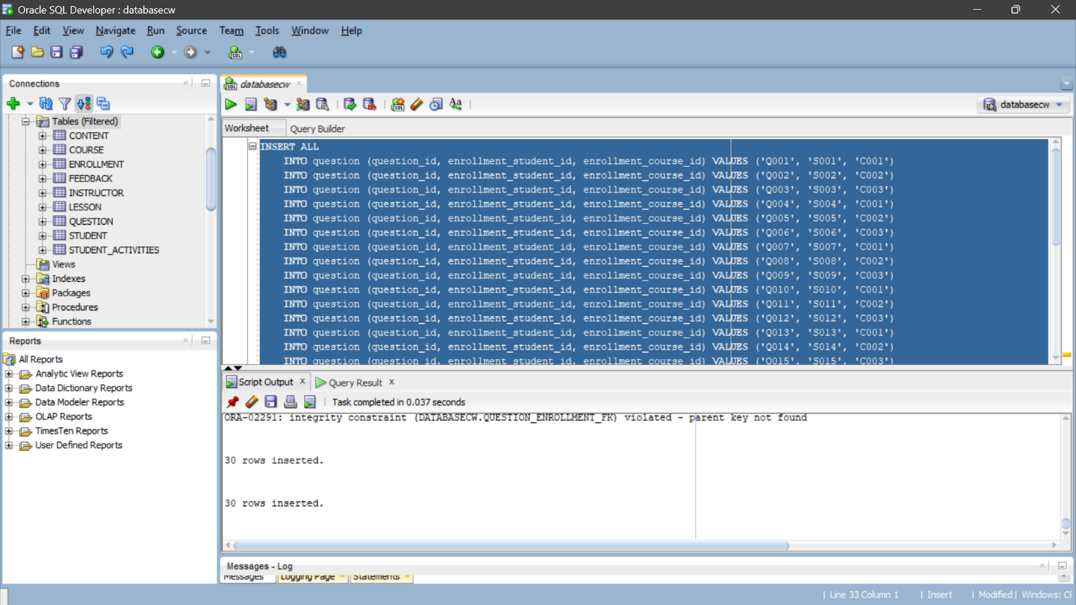SELECT * FROM DUAL;

Figure 10: Inserting value into question table

## Inserting value into feedback table

INSERT ALL

INTO feedback (feedback_id, feedback, instructor_id, question_id) VALUES ('F001', 'Good explanation', 'I001', 'Q001')

INTO feedback (feedback_id, feedback, instructor_id, question_id) VALUES ('F002', 'Very helpful', 'I002', 'Q002')

INTO feedback (feedback_id, feedback, instructor_id, question_id) VALUES ('F003', 'Could be clearer', 'I003', 'Q003')

INTO feedback (feedback_id, feedback, instructor_id, question_id) VALUES ('F004', 'Excellent!', 'I004', 'Q004')

INTO feedback (feedback_id, feedback, instructor_id, question_id) VALUES ('F005', 'Not satisfied', 'I005', 'Q005')

INTO feedback (feedback_id, feedback, instructor_id, question_id) VALUES ('F006', 'Great teaching style', 'I006', 'Q006')

INTO feedback (feedback_id, feedback, instructor_id, question_id) VALUES ('F007', 'Poor communication', 'I007', 'Q007')

INTO feedback (feedback_id, feedback, instructor_id, question_id) VALUES ('F008', 'Very knowledgeable', 'I008', 'Q008')

INTO feedback (feedback_id, feedback, instructor_id, question_id) VALUES ('F009', 'I learned a lot', 'I009', 'Q009')

INTO feedback (feedback_id, feedback, instructor_id, question_id) VALUES ('F010', 'Too fast-paced', 'I010', 'Q010')

INTO feedback (feedback_id, feedback, instructor_id, question_id) VALUES ('F011', 'Not enough examples', 'I011', 'Q011')

INTO feedback (feedback_id, feedback, instructor_id, question_id) VALUES ('F012', 'Needs improvement', 'I012', 'Q012')

INTO feedback (feedback_id, feedback, instructor_id, question_id) VALUES ('F013', 'Awesome!', 'I013', 'Q013')

INTO feedback (feedback_id, feedback, instructor_id, question_id) VALUES ('F014', 'Dont understand', 'I014', 'Q014')

INTO feedback (feedback_id, feedback, instructor_id, question_id) VALUES ('F015', 'Could explain better', 'I015', 'Q015')

INTO feedback (feedback_id, feedback, instructor_id, question_id) VALUES ('F016', 'Very engaging', 'I016', 'Q016')

INTO feedback (feedback_id, feedback, instructor_id, question_id) VALUES ('F017', 'Terrible!', 'I017', 'Q017')

INTO feedback (feedback_id, feedback, instructor_id, question_id) VALUES ('F018', 'Helped me a lot', 'I018', 'Q018')

INTO feedback (feedback_id, feedback, instructor_id, question_id) VALUES ('F019', 'Could be more interactive', 'I019', 'Q019')

INTO feedback (feedback_id, feedback, instructor_id, question_id) VALUES ('F020', 'I enjoyed it', 'I020', 'Q020')

INTO feedback (feedback_id, feedback, instructor_id, question_id) VALUES ('F021', 'Could improve pacing', 'I021', 'Q021')

INTO feedback (feedback_id, feedback, instructor_id, question_id) VALUES ('F022', 'Not worth it', 'I022', 'Q022')

INTO feedback (feedback_id, feedback, instructor_id, question_id) VALUES ('F023', 'Outstanding!', 'I023', 'Q023')

INTO feedback (feedback_id, feedback, instructor_id, question_id) VALUES ('F024', 'Didnt meet expectations', 'I024', 'Q024')

INTO feedback (feedback_id, feedback, instructor_id, question_id) VALUES ('F025', 'Very informative', 'I025', 'Q025')

INTO feedback (feedback_id, feedback, instructor_id, question_id) VALUES ('F026', 'Hard to follow', 'I026', 'Q026')

INTO feedback (feedback_id, feedback, instructor_id, question_id) VALUES ('F027', 'Best course ever', 'I027', 'Q027')

INTO feedback (feedback_id, feedback, instructor_id, question_id) VALUES ('F028', 'Loved it!', 'I028', 'Q028')

INTO feedback (feedback_id, feedback, instructor_id, question_id) VALUES ('F029', 'Could use more resources', 'I029', 'Q029')

INTO feedback (feedback_id, feedback, instructor_id, question_id) VALUES ('F030', 'Would not recommend', 'I030', 'Q030')

SELECT * FROM DUAL;

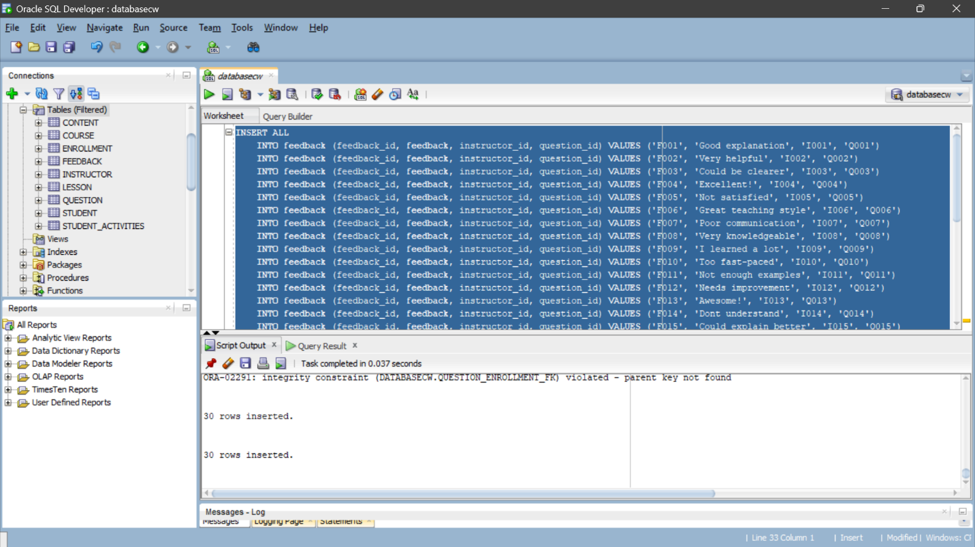

Figure 11: Inserting value into feedback table

# Select Statement

## Selecting Data from Students table

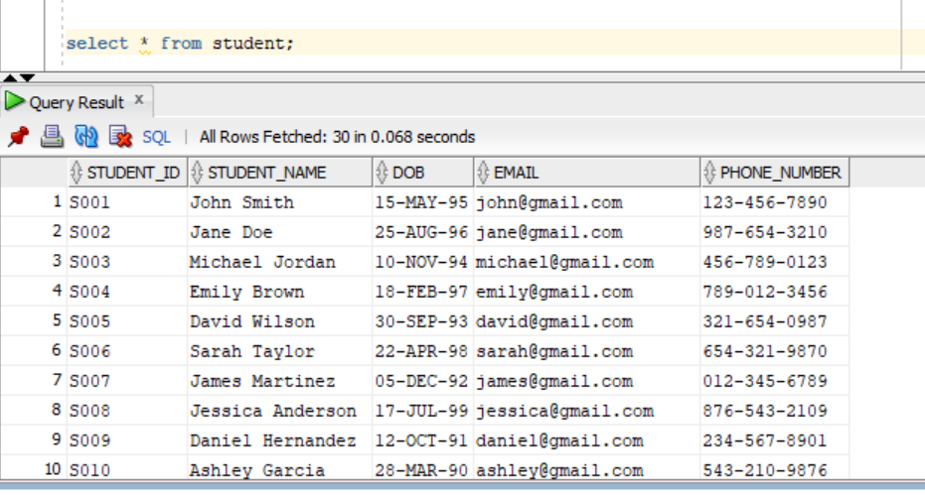

Figure 12: Selecting Data from Students table

## Selecting Data from Course table

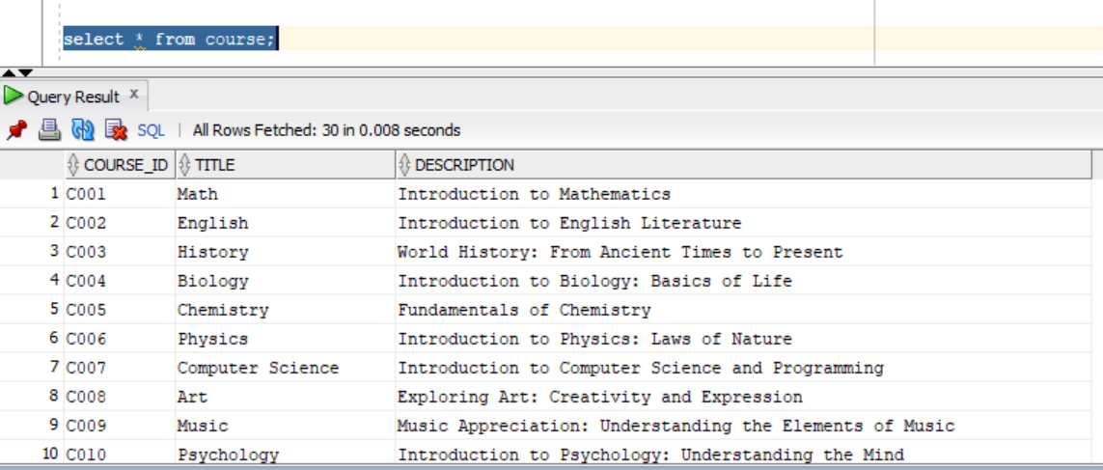

Figure 13: Selecting Data from course table

## Selecting Data from Course table

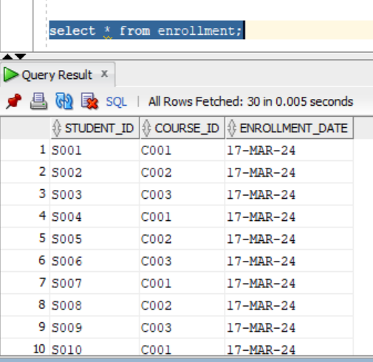

Figure 14: Selecting Data from Course table

## Selecting Data from Content table

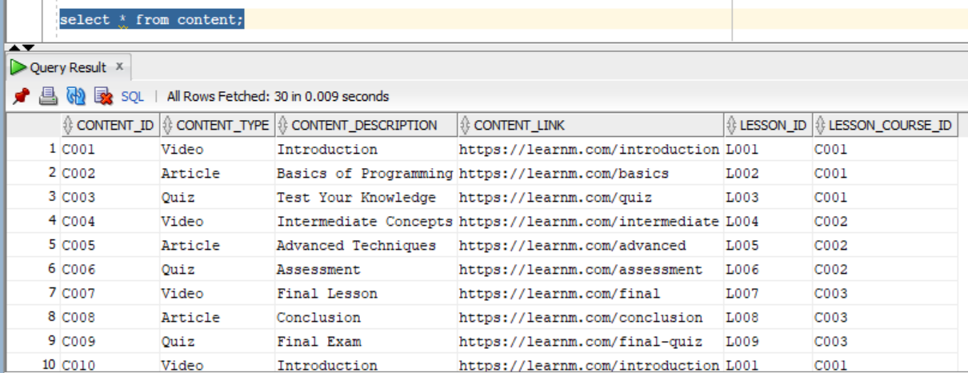

Figure 15: Selecting Data from Content table

## Selecting Data from Feedback table

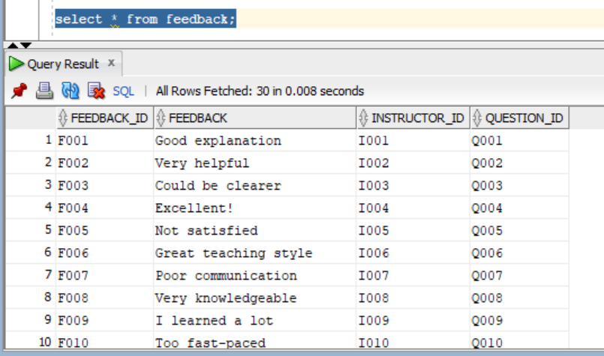

Figure 16: Selecting Data from feedback table

## Selecting Data from Instructors table

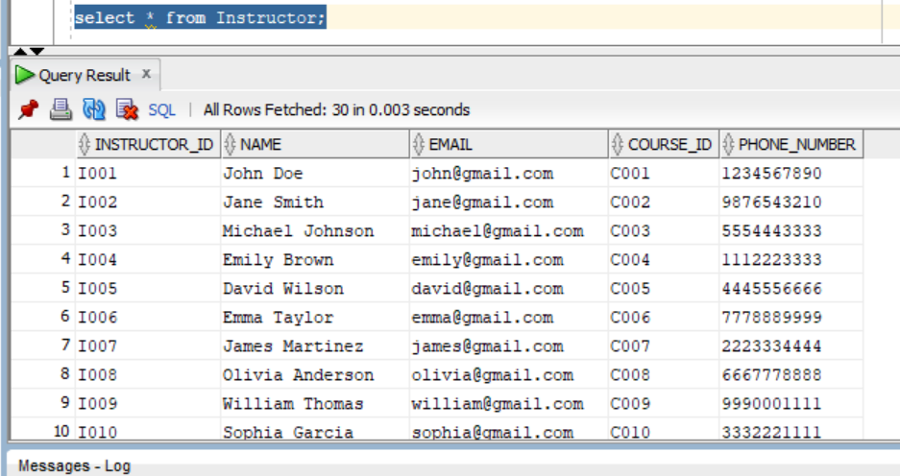

Figure 17: Selecting Data from instructors table

## Selecting Data from Lesson table

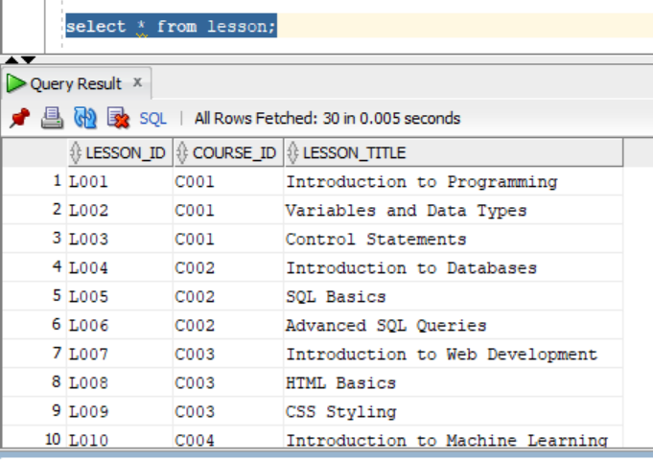

Figure 18: Selecting Data from lesson table

## Selecting Data from Question table

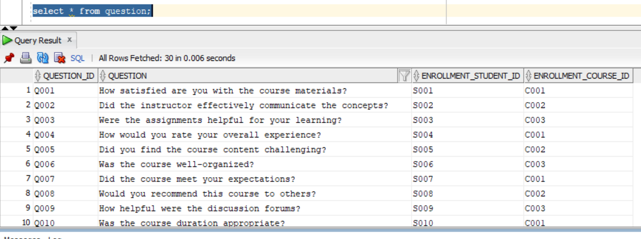

Figure 19: Selecting Data from Question table

## Selecting Data from Student activities table

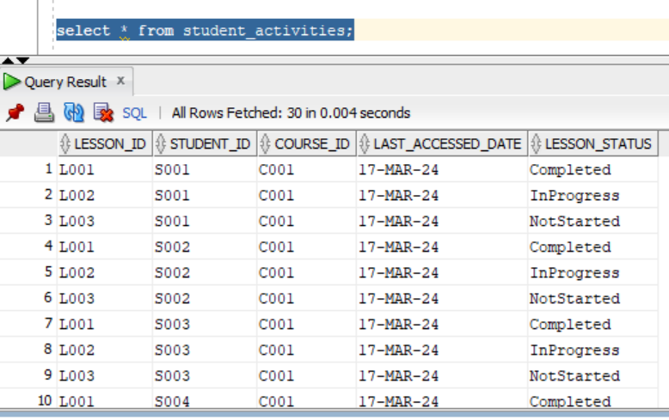

Figure 20: Selecting Data from Student activities table

# Implementation of Web-based Database Application

## Basic Webforms

### Student Details

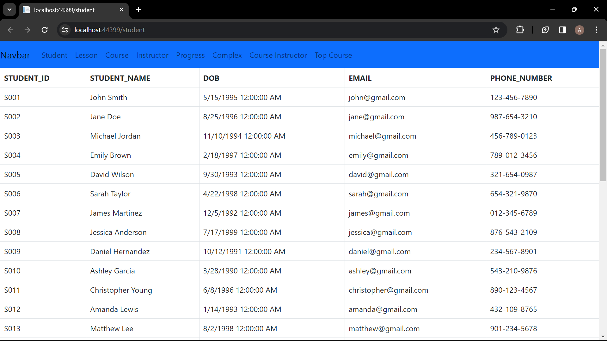

Figure 21: Students web form

### Instructor Details

### Course detail

Figure 22: Instructor detail web form

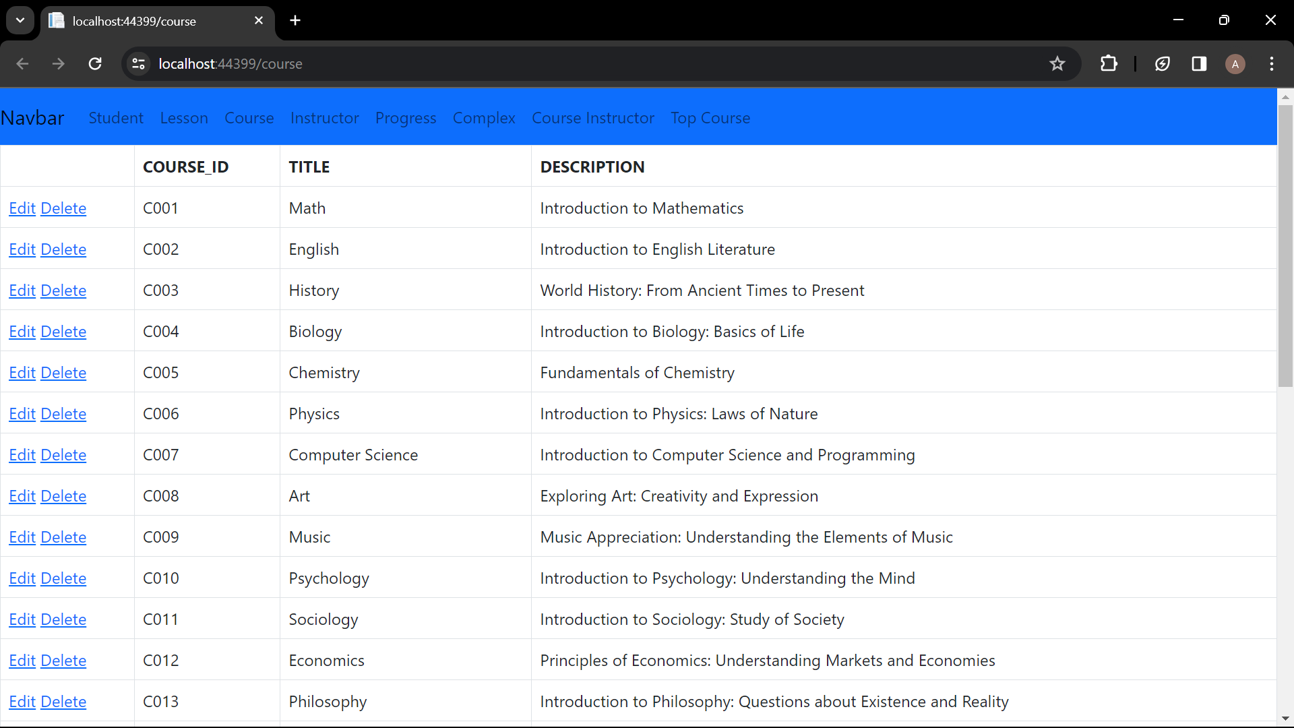

Figure 23: Course details webform

### Lesson details

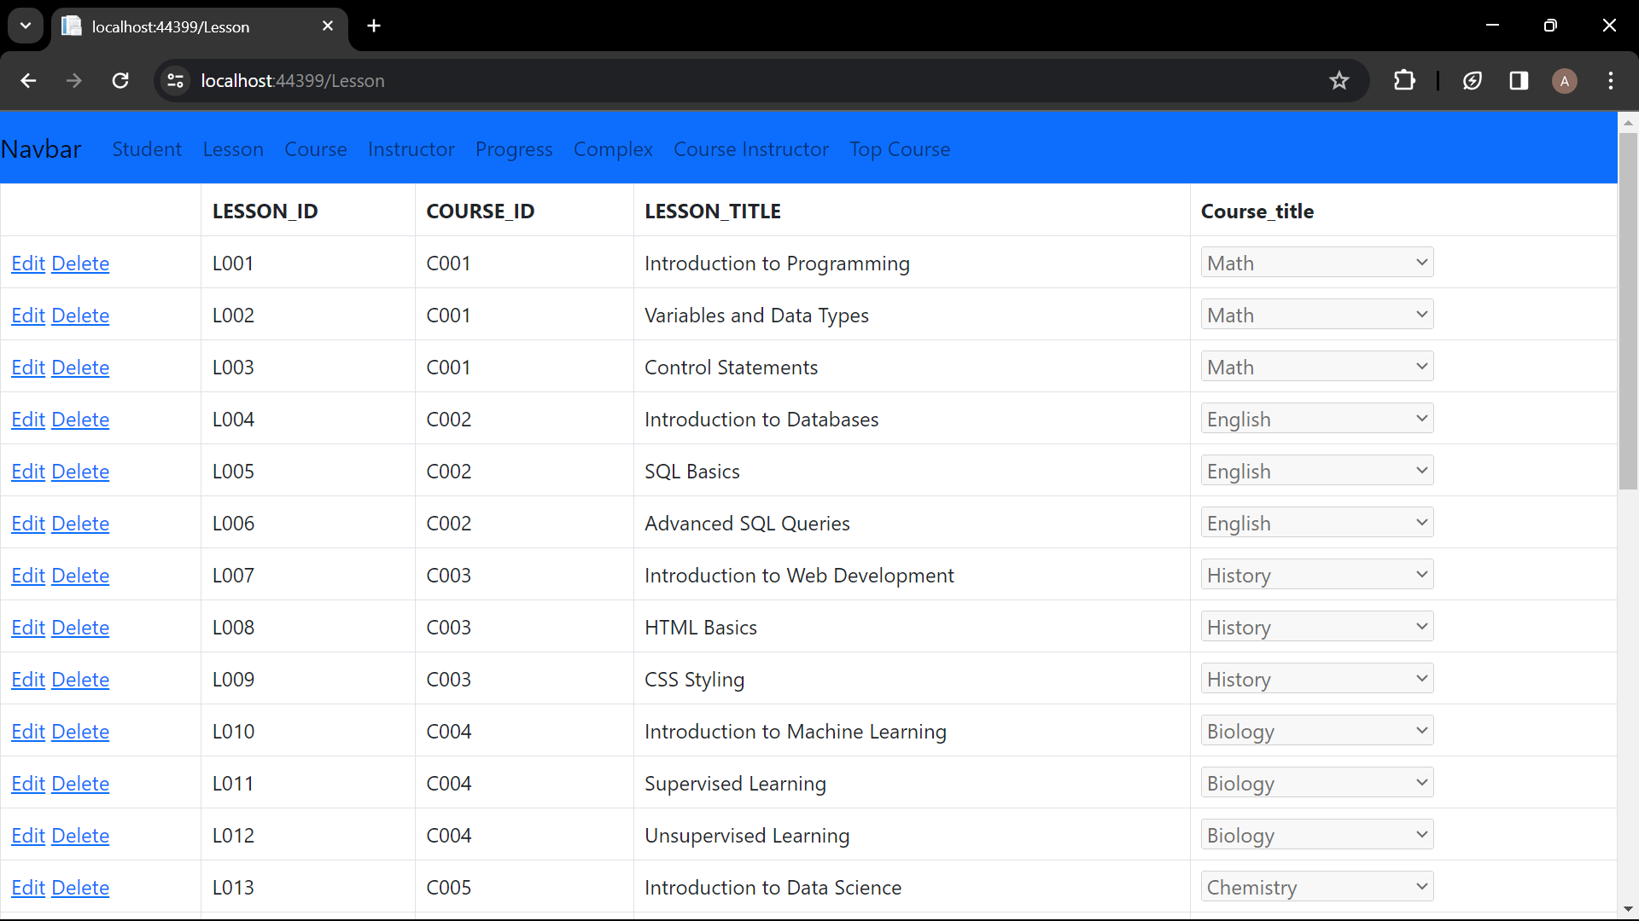

Figure 24: Lesson detail webform

### Progress details

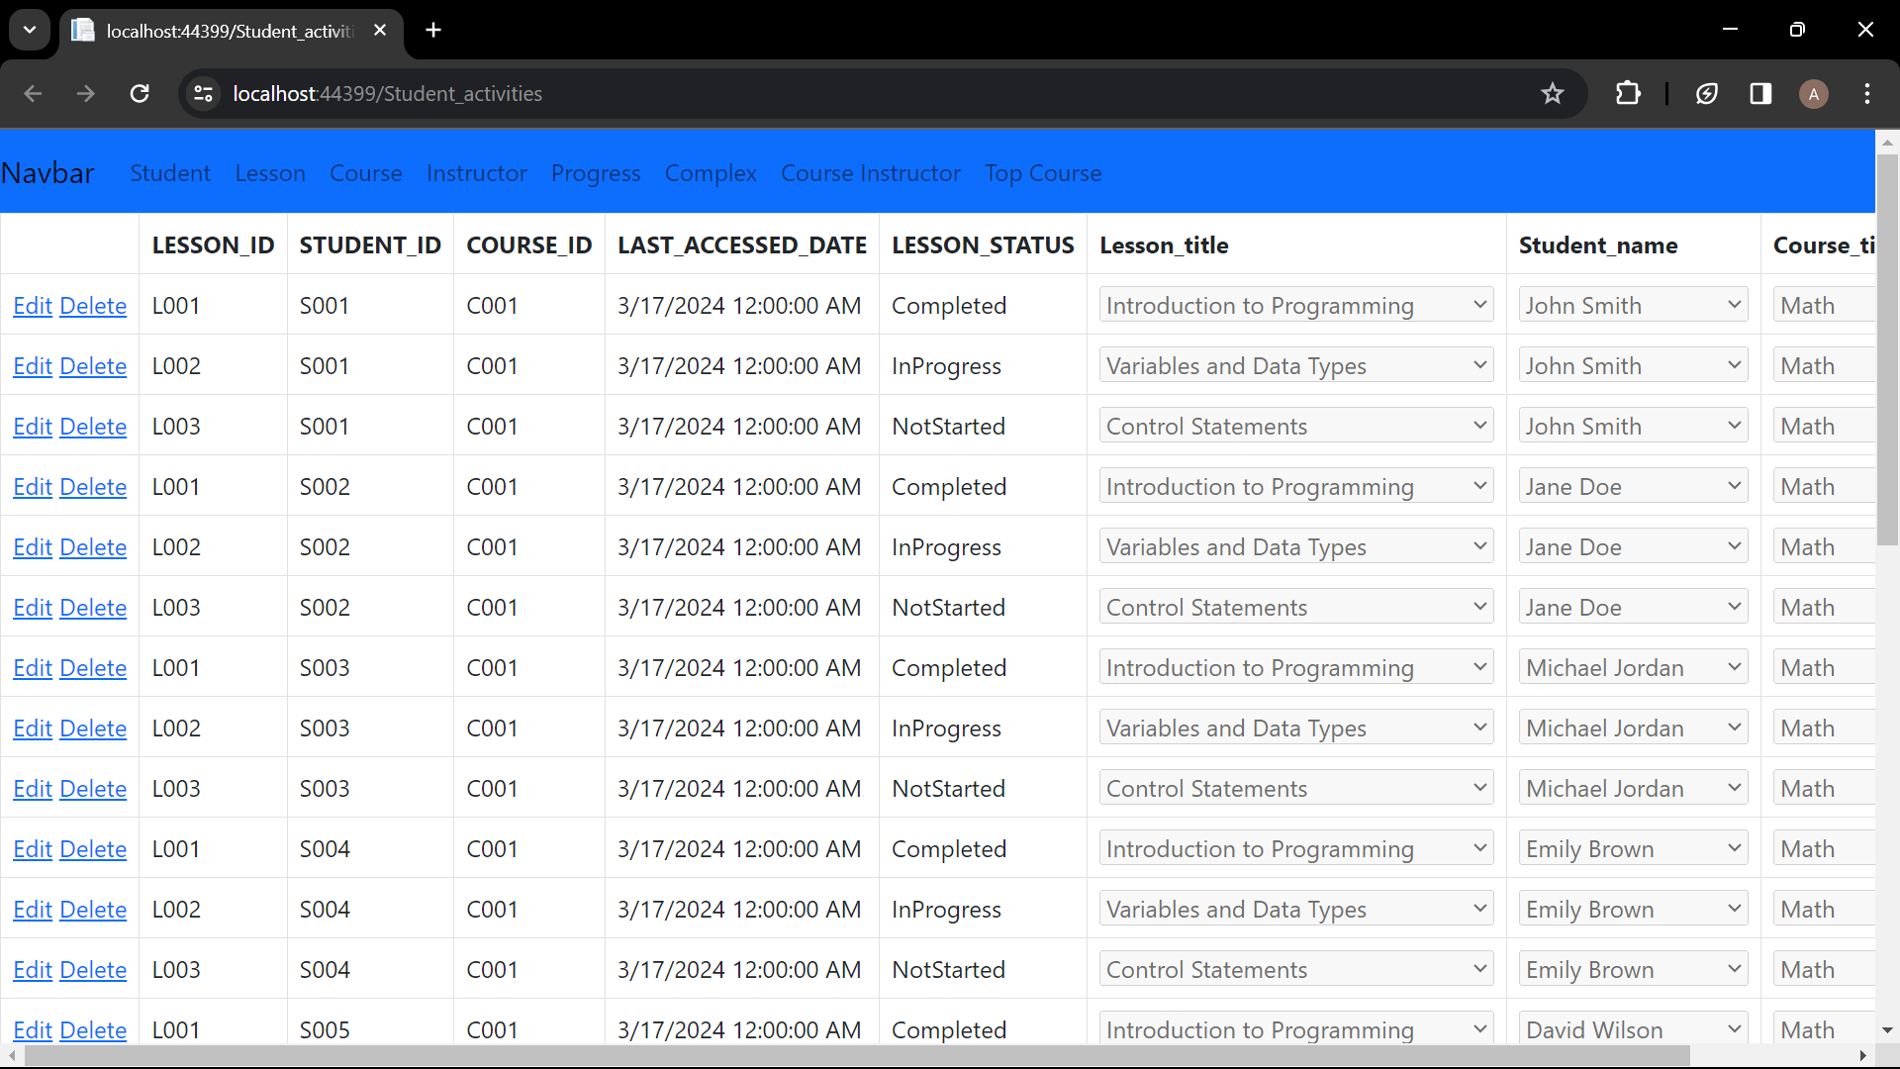

Figure 25: Progress details webform

## Complex Webform

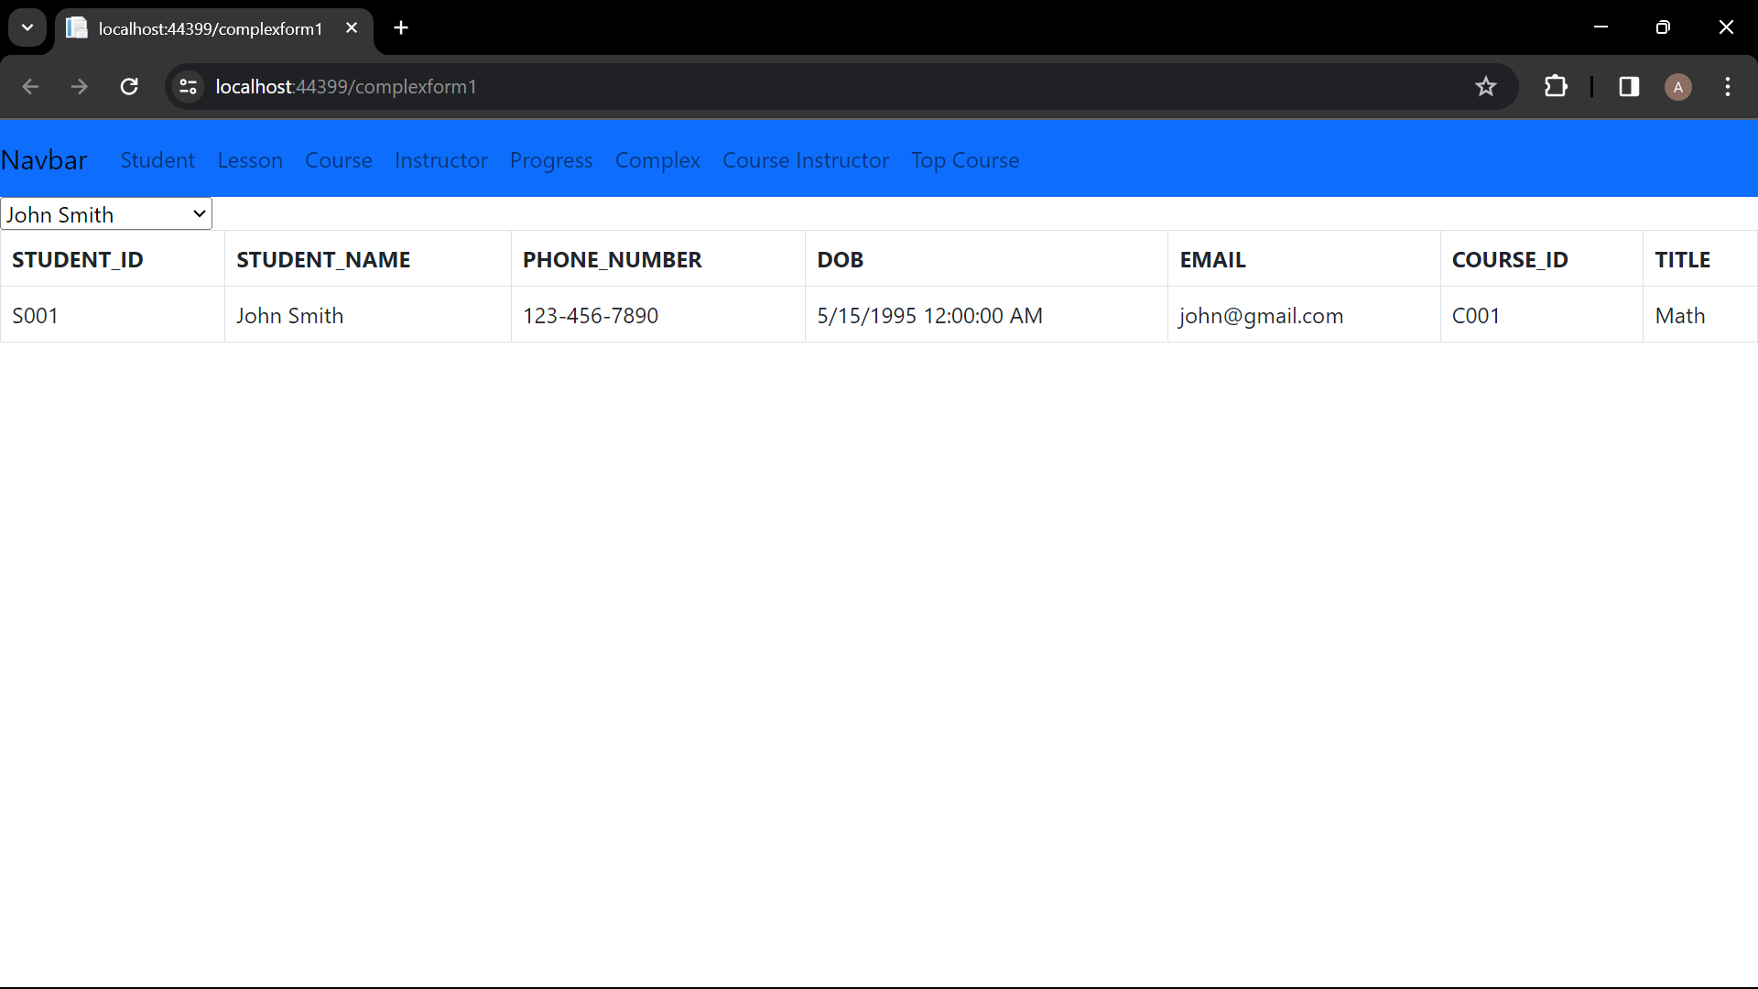

Figure 26: Student enrollment webform

# Forms

## Home page

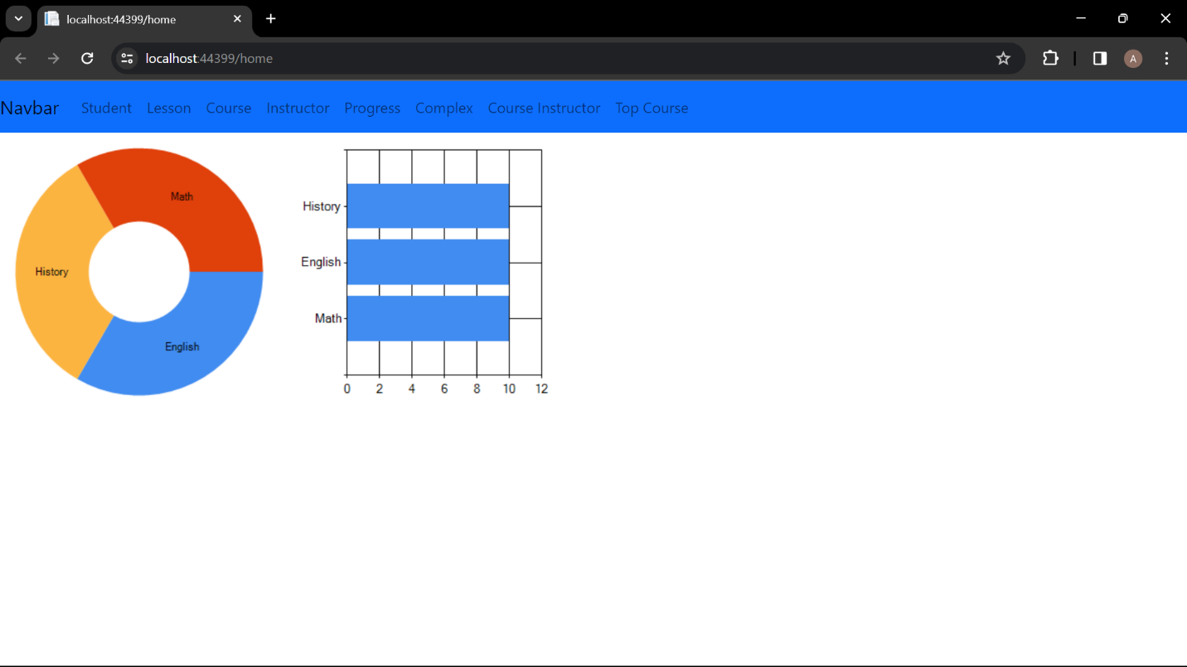

Figure 27: Home Page

## Complex Form

### Student Enrollment

SQL Query:

SELECT s.STUDENT_ID, s.STUDENT_NAME, s.PHONE_NUMBER, s.DOB, s.EMAIL,

e.COURSE_ID, c.TITLE

FROM student s

JOIN enrollment e ON s.STUDENT_ID = e.STUDENT_ID

JOIN course c ON e.COURSE_ID = c.COURSE_ID where s.STUDENT_ID= :student



Figure 28: Complex Form 1

### Course Instructor

SQL query:

select c.course_id, c.title, c.description, i.instructor_id, i.name as instructor_name from course c join instructor i on c.course_id = i.course_id order by c.course_id, i.instructor_id

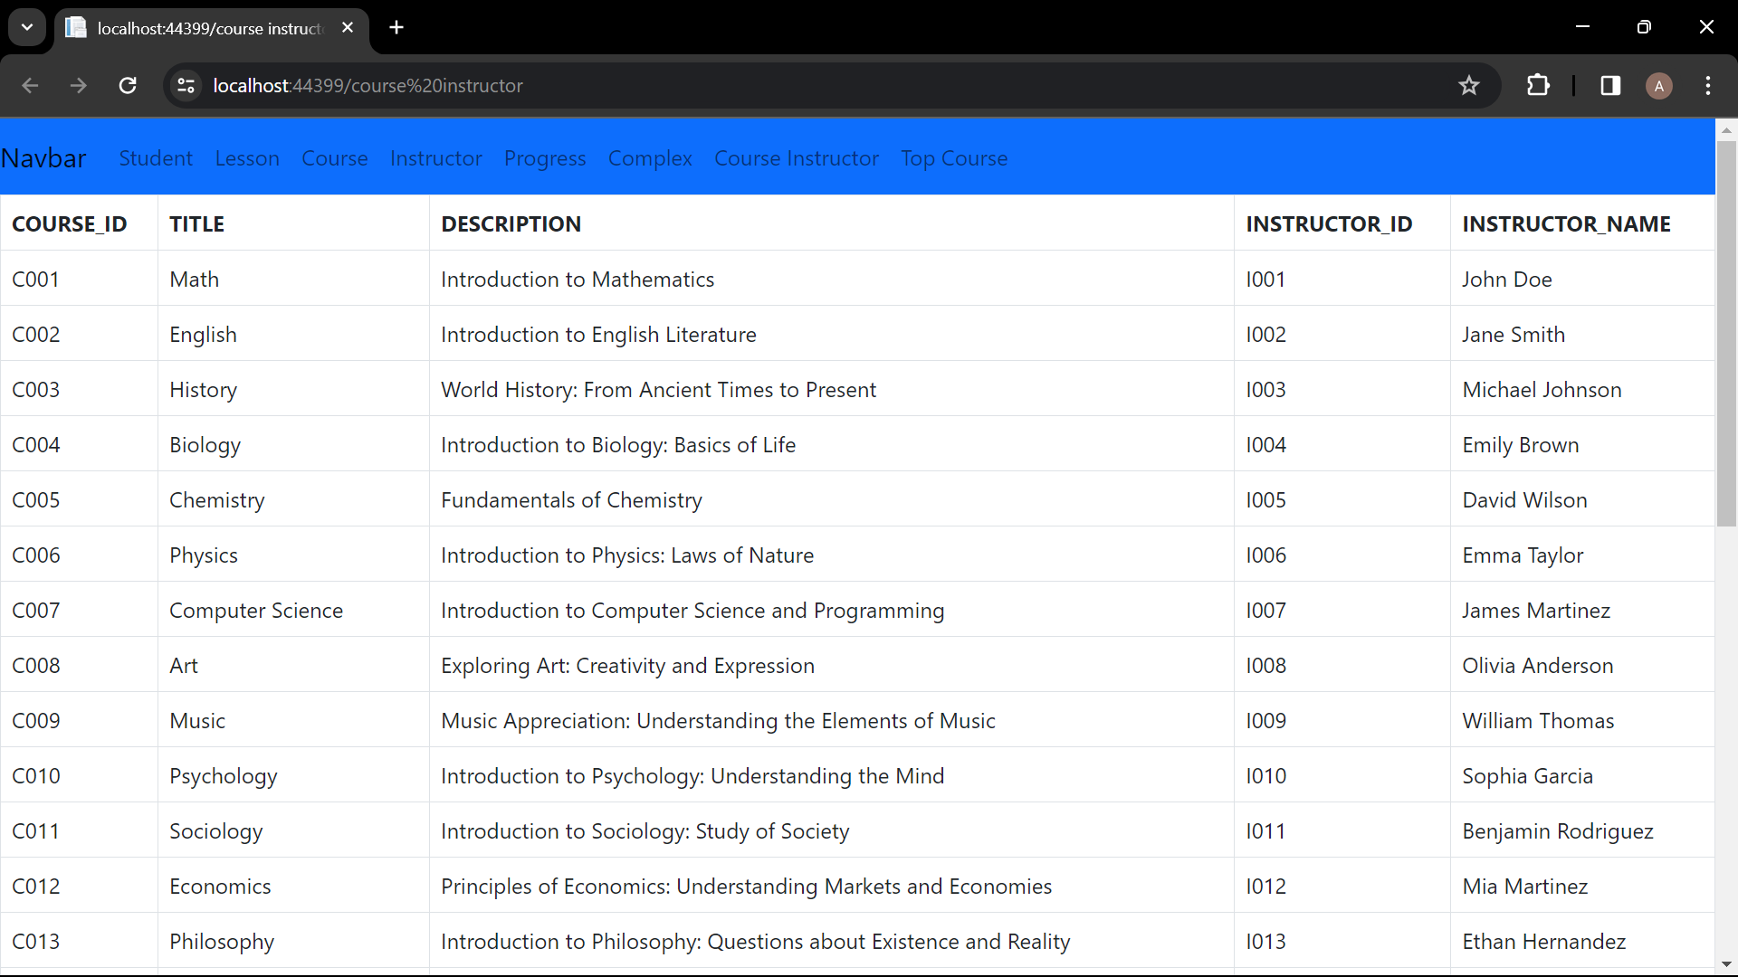

Figure 29: Complex form 2

### Top Course

SQL query:

select * from ( select c.course_id, c.title, count(e.student_id) as enrollments_count from course c join enrollment e on c.course_id = e.course_id where extract(month from e.enrollment_date) = :month and extract(year from e.enrollment_date) = :year group by c.course_id, c.title order by enrollments_count desc ) where rownum <= 3

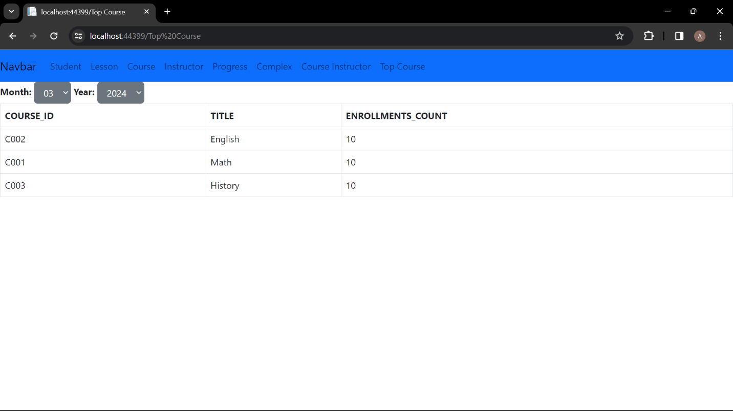

Figure 30: Complex form 3

# Testing

## Student Details:

Inserting:

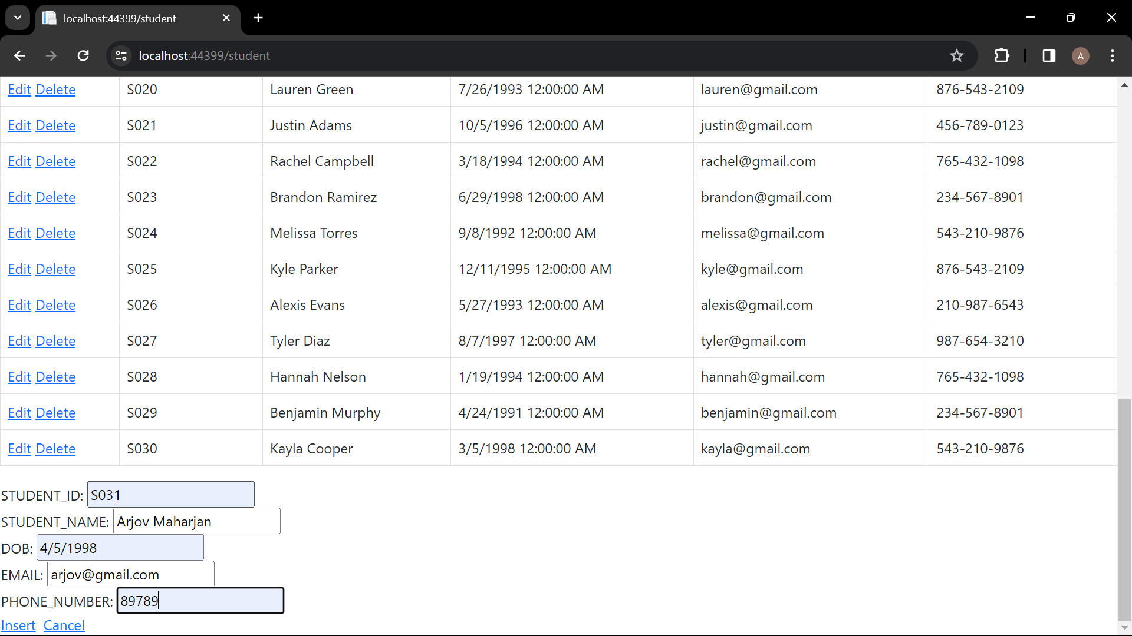

Figure 31: Inserting new student

Editing:

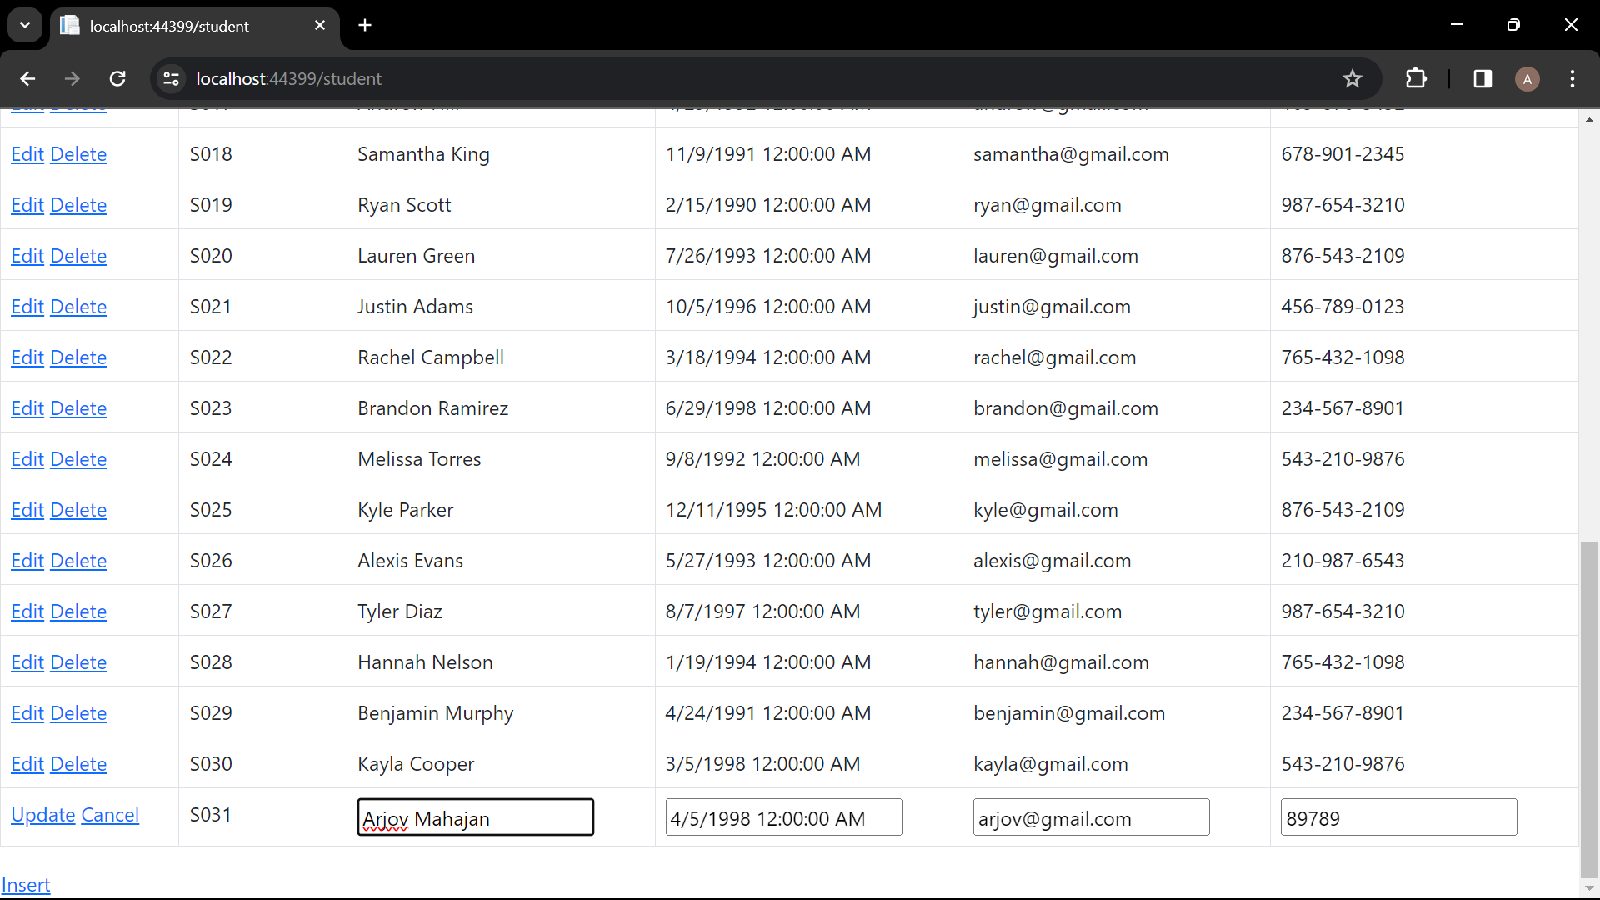

Figure 32: editing student details

Deleting:

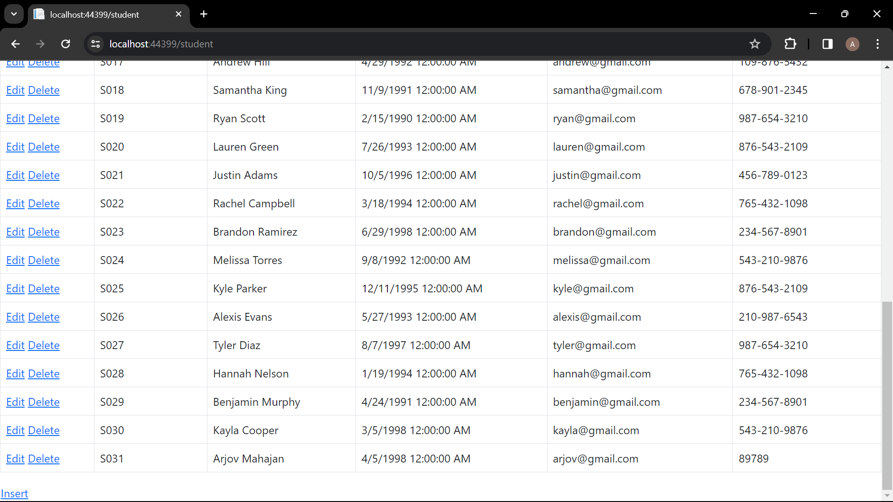

Figure 33: deleting the new student detail

## Lesson Details

Inserting new lesson:

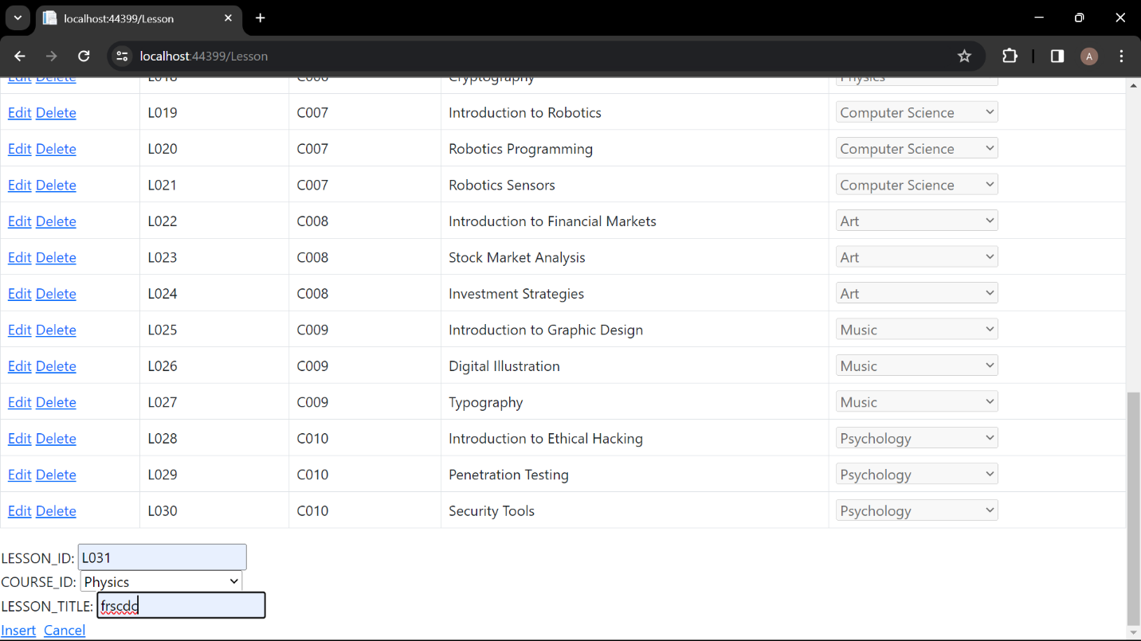

Figure 34: inserting

Editing:

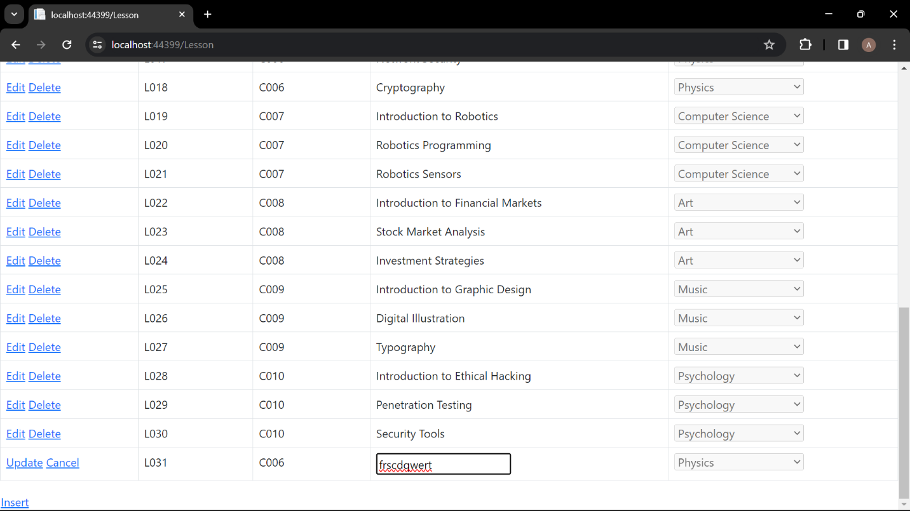

Figure 35: editing

Deleting:

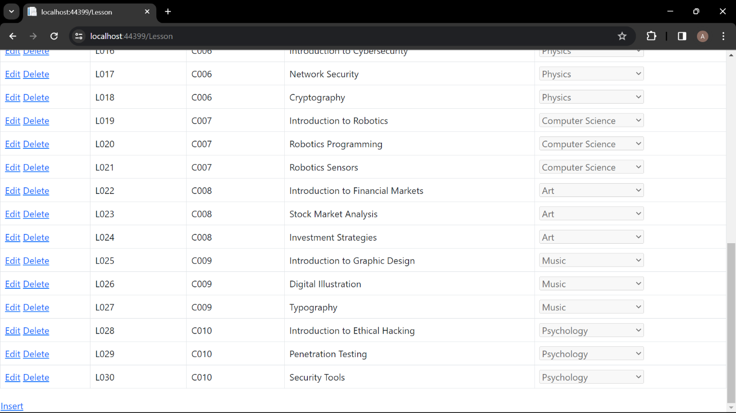

Figure 36: deleting

## Course page

Inserting:

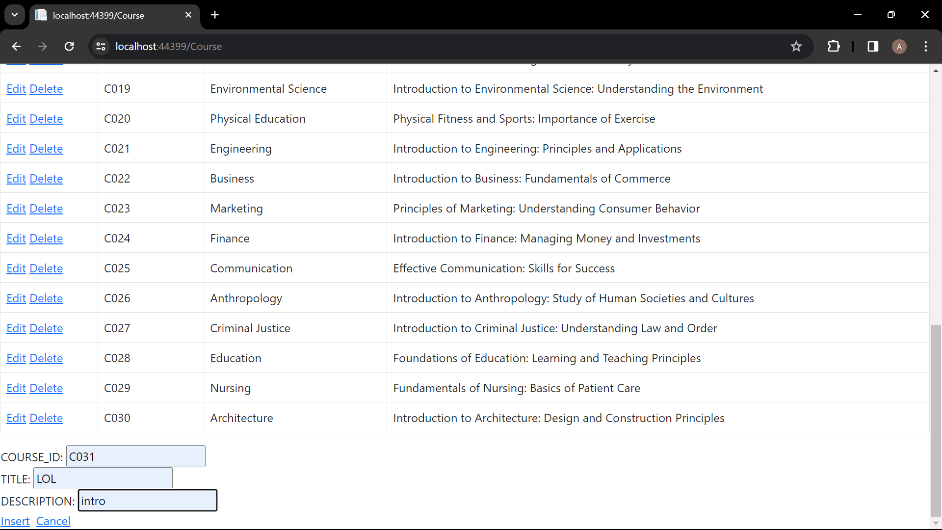

Figure 37: inserting

Editing:

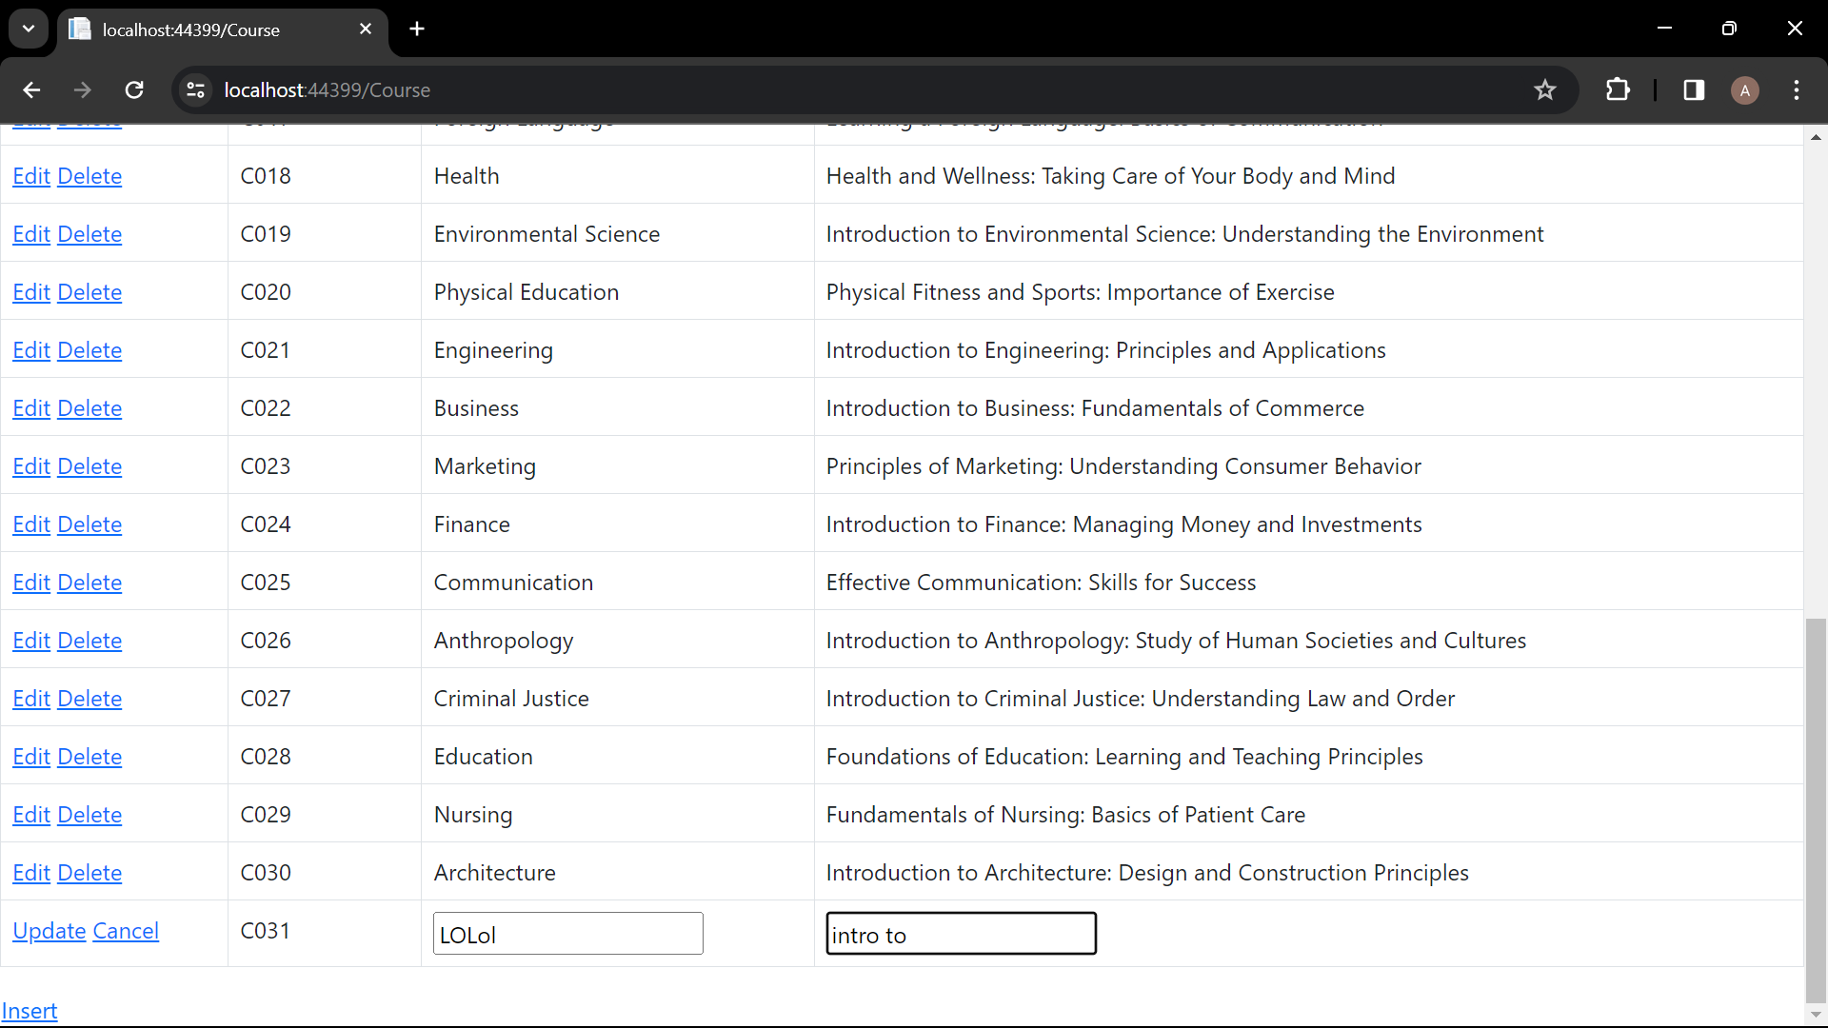

Figure 38: editing

Deleting:

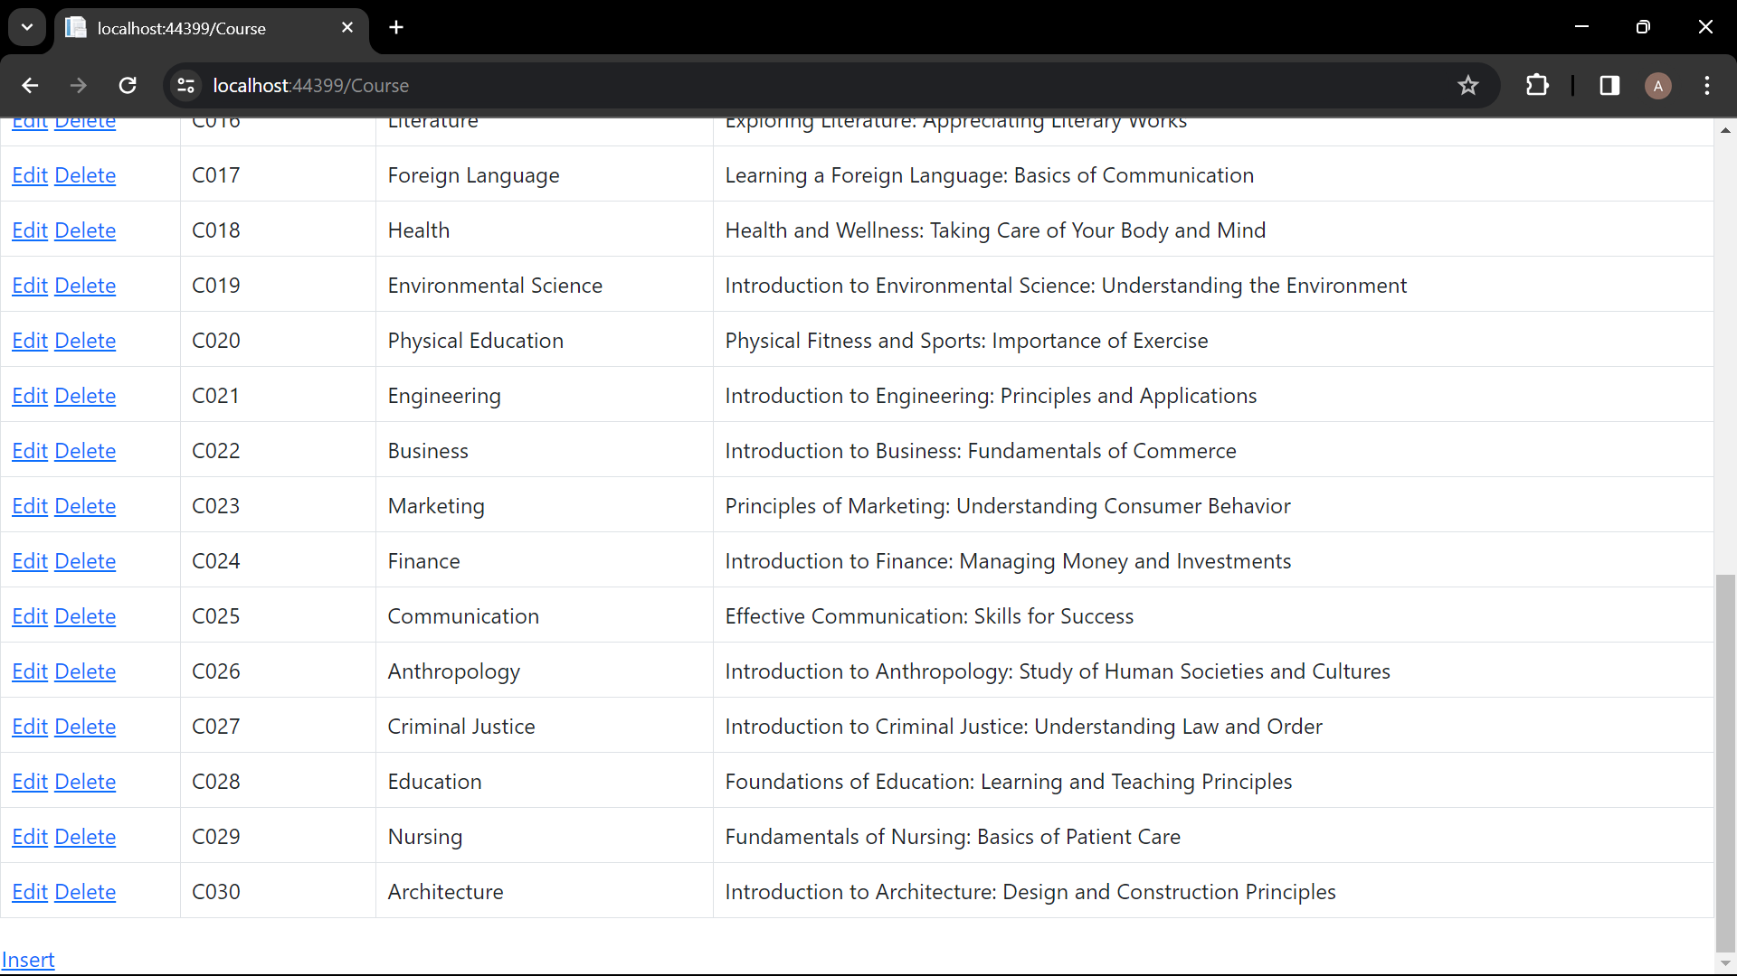

Figure 39: deleting

## Instructor page

Inserting:

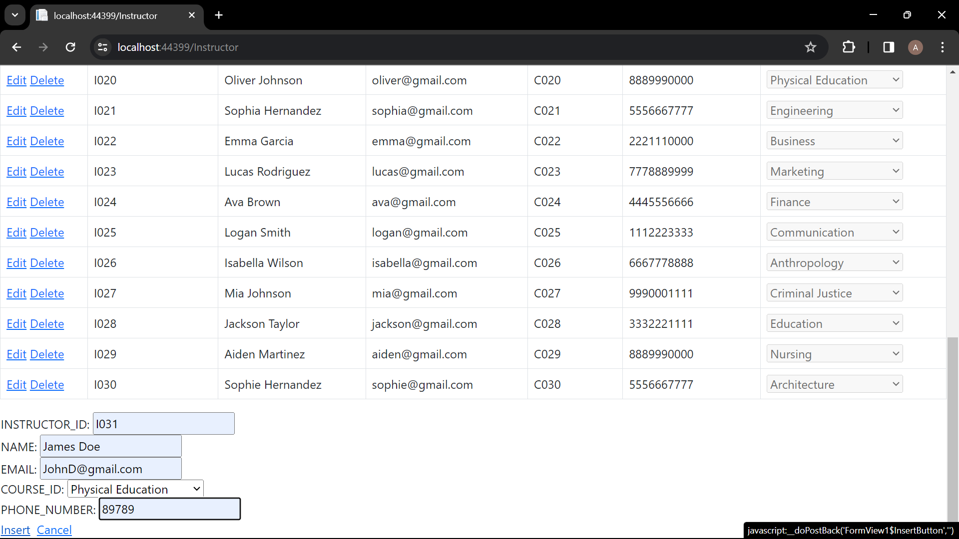

Figure 40: inserting

Editing:

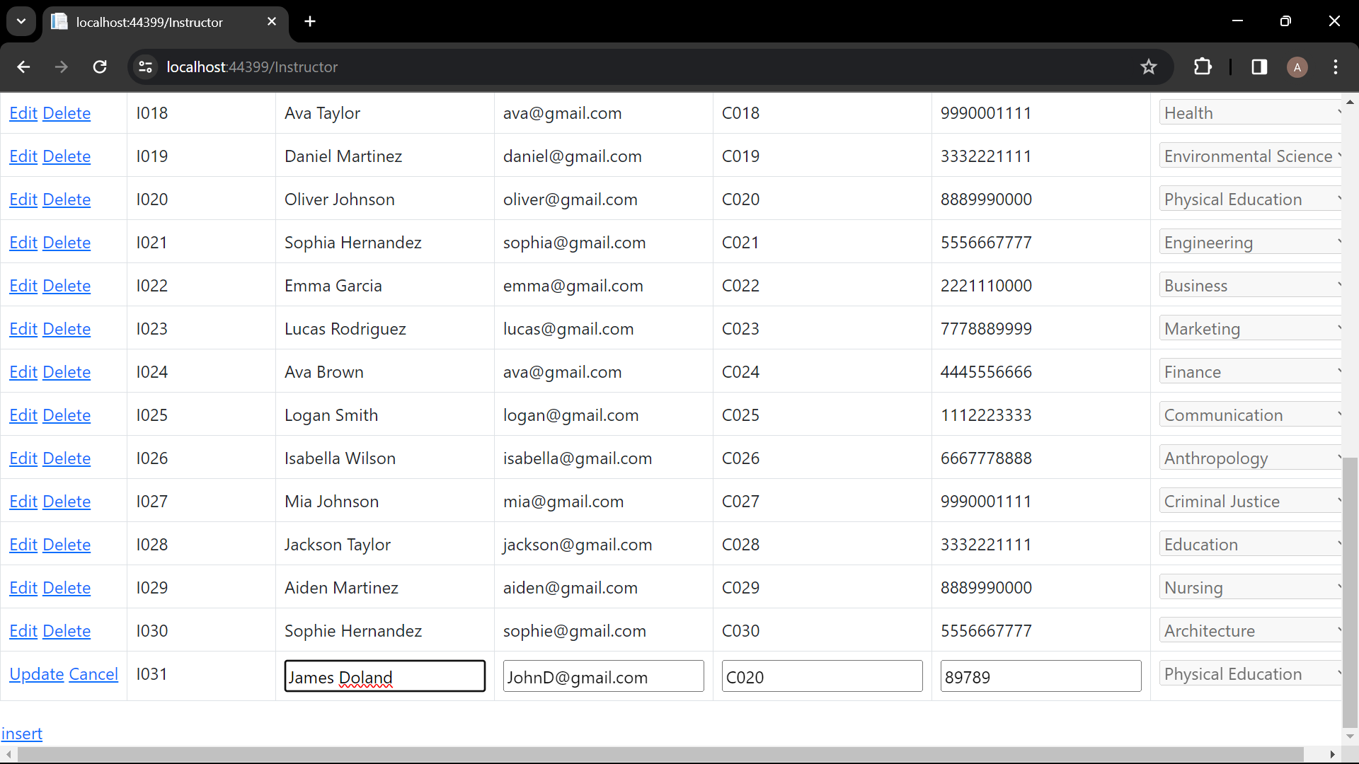

Figure 41: inserting

Deleting:

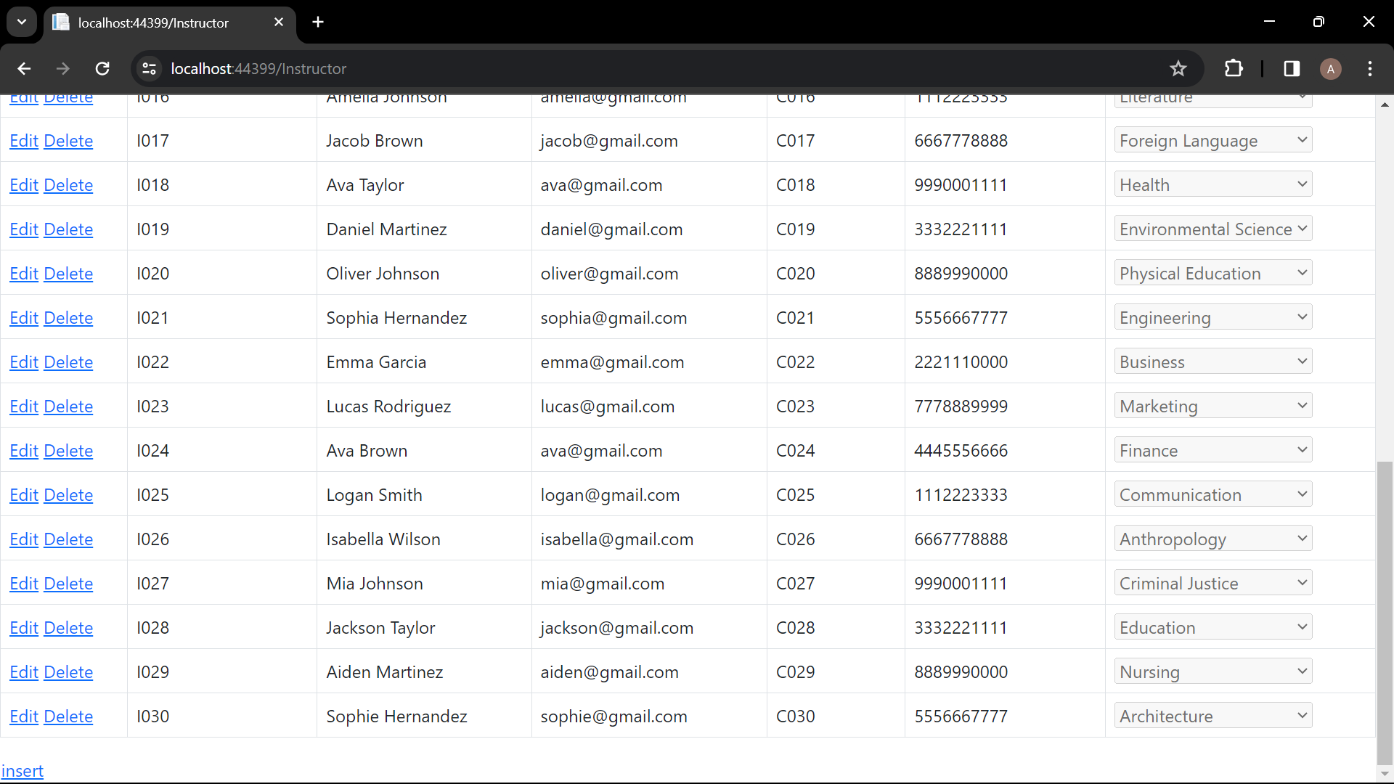

Figure 42: deleting

## Error:

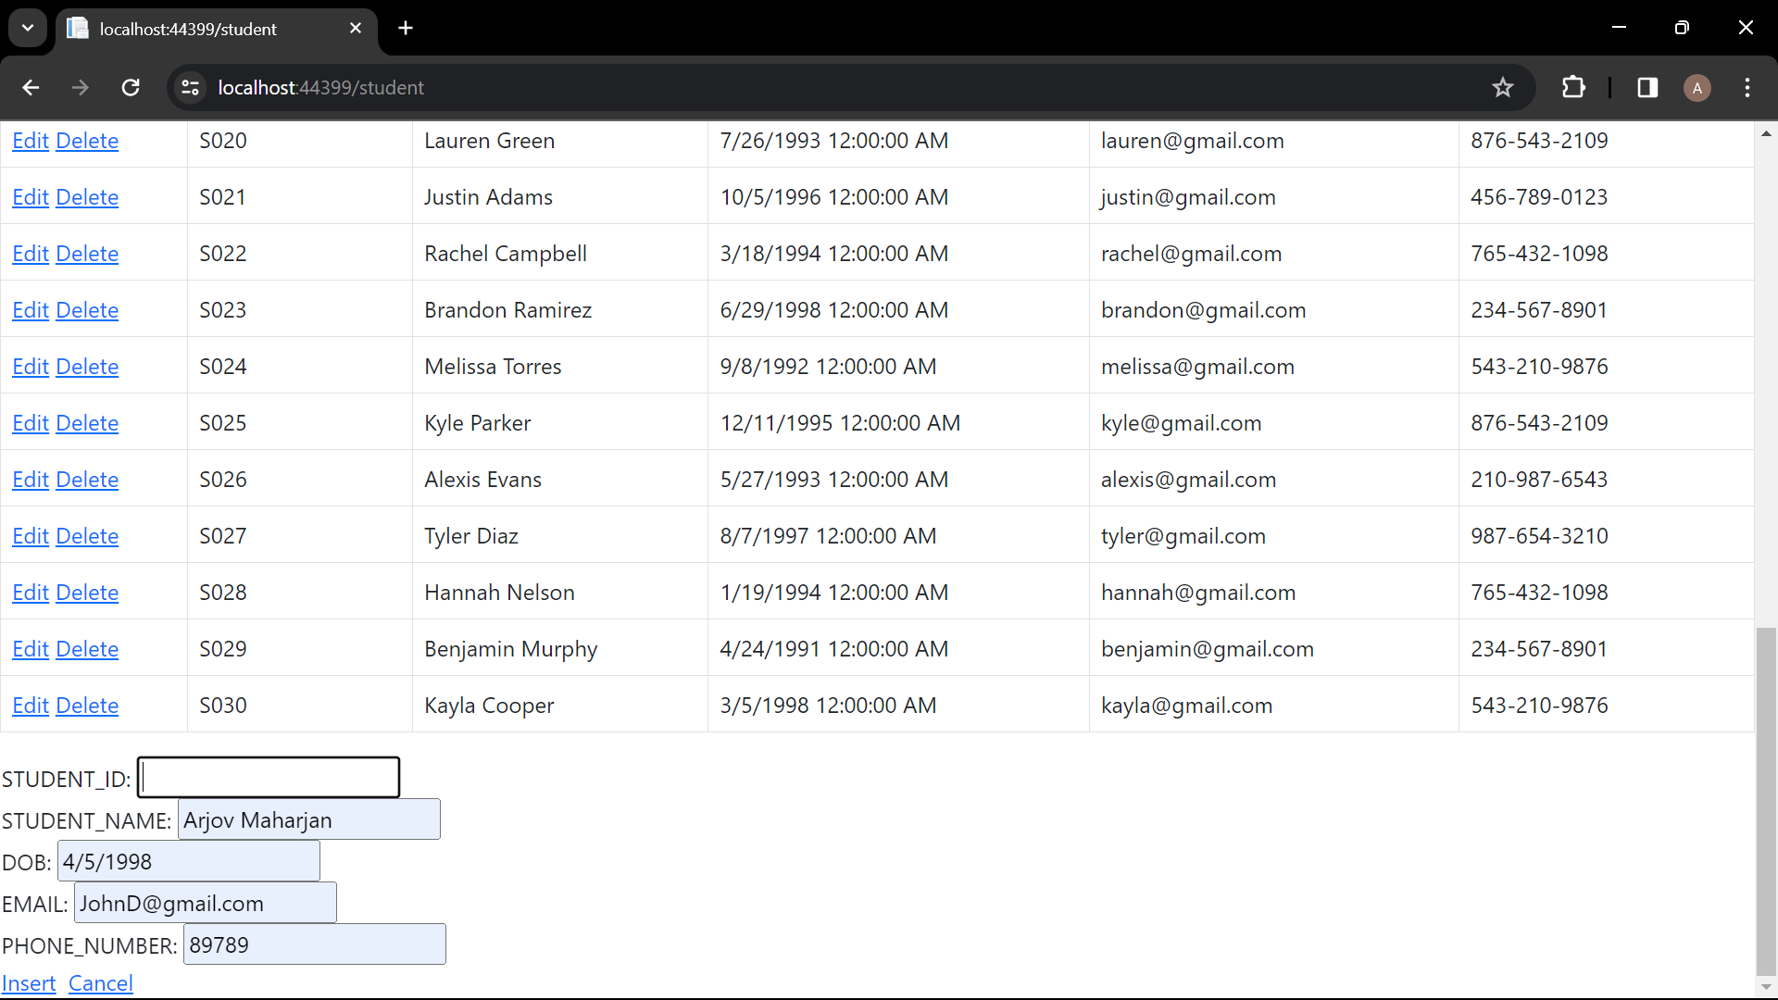

Figure 43: leaving one empty field

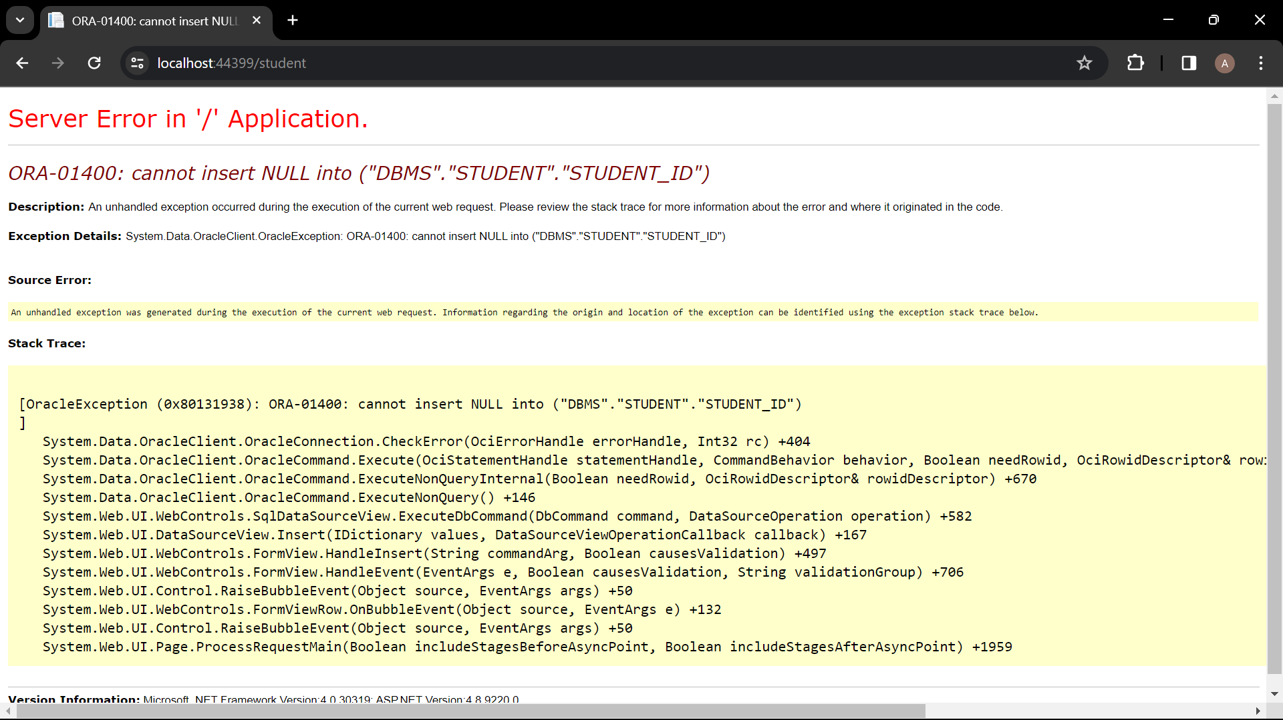

Figure 44: error

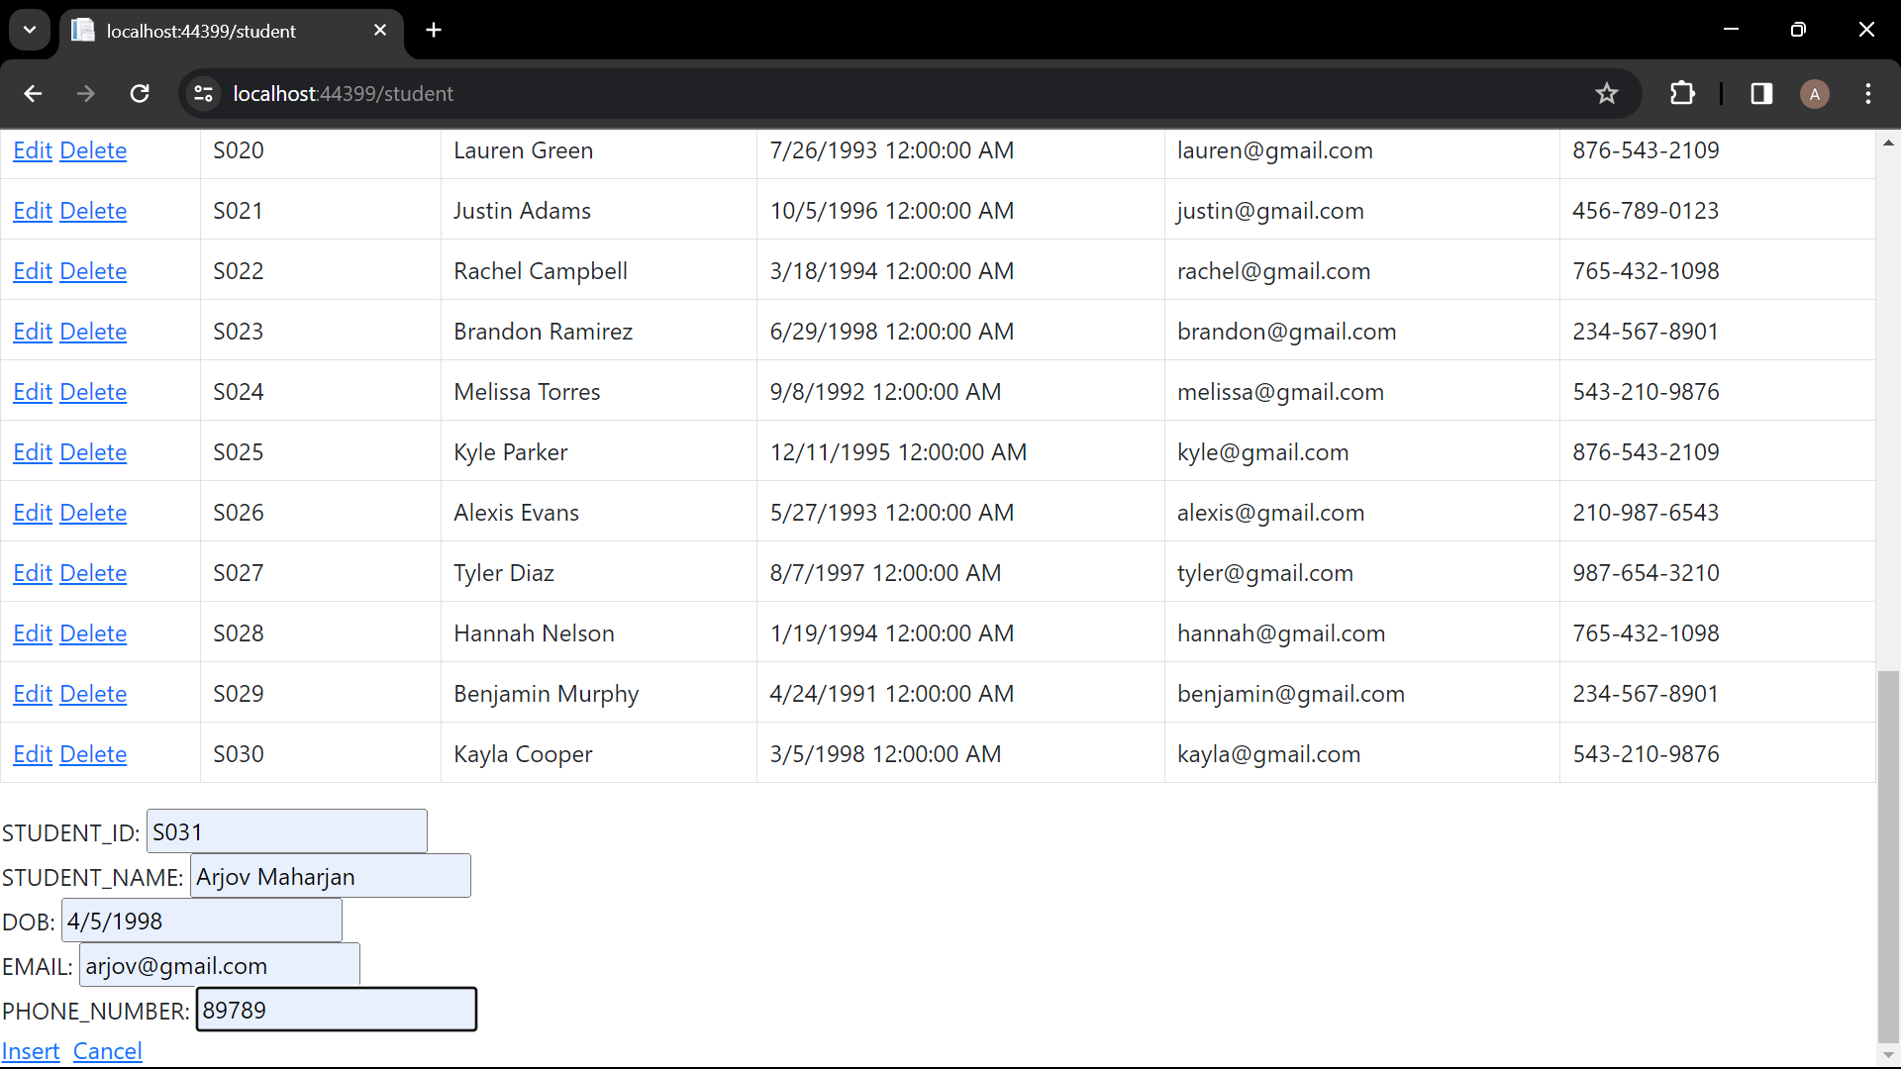

Figure 45: filling all the fields

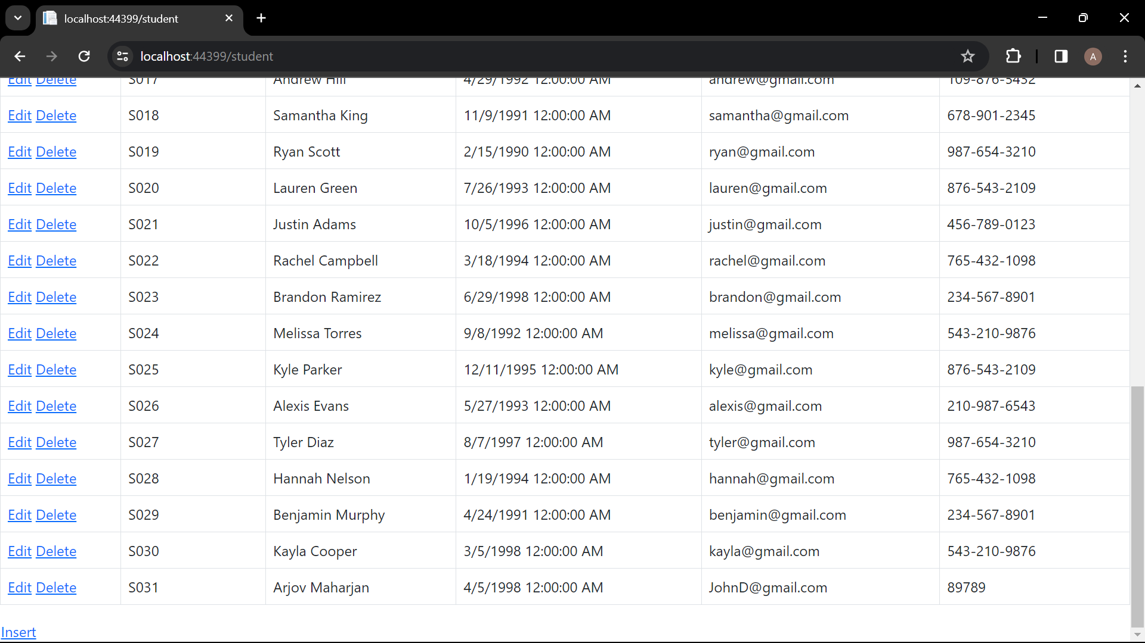

Figure 46: inserted successfully

# Conclusion

In conclusion, the project used ASP.NET with C# and Oracle SQL Developer Data Modeler to effectively construct an e-learning platform. The project has a strong database structure that effectively handles student enrollments, course progress tracking, and instructor-student interactions through thorough normalization and careful entity integration.   
  
Users may navigate and retrieve course materials with ease because to the web-based application's easy interfaces. Data integrity is preserved across the system by creating appropriate key relationships and following to normalization criteria.  
  
  
Although the study shows how contemporary technology may transform education, there is room for improvement going forward. These could include enhanced communication tools for teacher-student interactions and sophisticated analytics for tracking student achievement.

In conclusion, the program serves as an example of the revolutionary power of e-learning platforms in enabling learners all over the world to access and enjoy quality education. These platforms have the capacity to influence education in the future by enabling people to seek knowledge and skills outside of conventional limits with further development.